

PhD Final Model

2/14/2018

Ben Cohen



*(* - Problem Statement



_ Why this model helps

Questions to be

Introduction leads to Why this Model is Relevant?

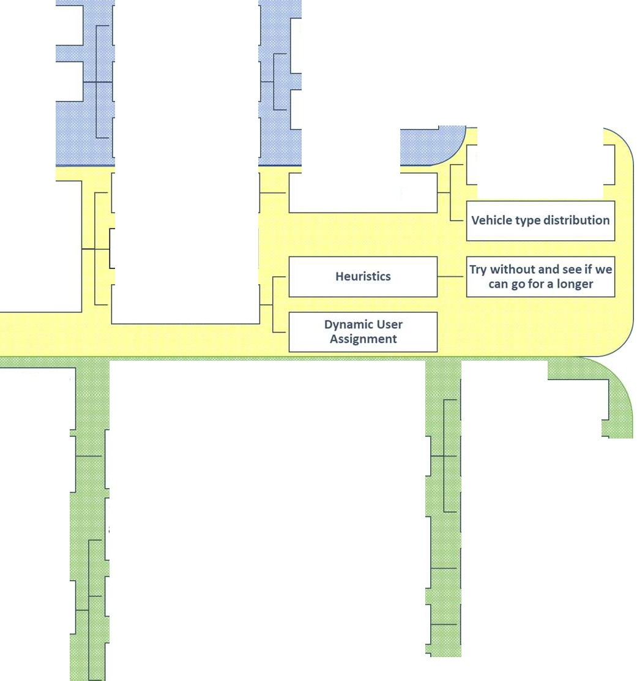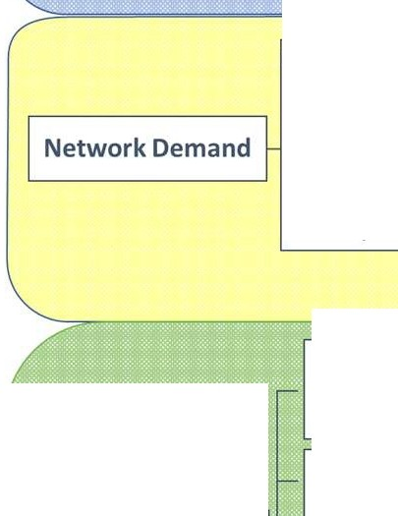

at all?

Background and

answered

Very relevant papers or projects

Transportation Asset

Management

- Literature Review ABM and Hybrid Models

Literature Review .. P_a_p_e_r_s_B_v_l_o_p_ic ,

Etc..

Description of virtual network



VirtualNetwork

Why SUMO Physical layout- OSM

Roadway

Names;lane width, max speed; permissions;etc...

Components

parameterization

Show Dataframe

Description_

of_Network

_Demand

• Users

• Routes

• veh per

hour

• types

• etc...

0 agent HQ locations

Calibrators Data sources

Users Behavior

Routes

Specific roadway flow counts

Infrastructure Asset

*Description of Owner Agent Purpose Capabilities*

Operation Research Scheduling Decision Module

Description of how the schedule will be made inputs outputs

Objective Function

Scenarios to run Constraints

Own Agent Description of how 0 agent interacts with V

network

metrics

Physical

Representation of

VirtualNetwork

Modification Module

True to constraints of

OR Schedule

workforce enforces

logic controls

Work crews like buses

with special stops

Python Code TRAci Python SUMO Interface

Link back to network

parameters

:-:·:=:· :::. :

0 agent collects simulation network run data for OR module

Frequency and Accuracy of update based on agent characteristics

Home Intro_N_Background The _ModeI Virtual_Network Network_Demand Network_Owner_N_Management

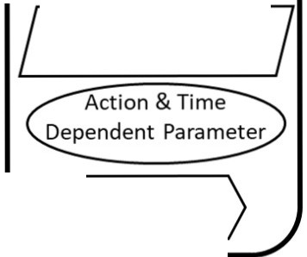

Agent Environment

Agent

**Legend**

( Static Parameter J

**SUMO Drivers Infrastructure Asset Infrastructure Owners**

Type

Characteristics *I*

Rules of behavior

Physical

Attributes

Environmental

Attributes

modifies

Maintenance

Activity

TAMP Activity

Schedule

Time Dependent

Parameter

LOS Expectations Deterioration Rate

Condition

Rating

Risk

Action Trigger

Policy

Objectives

< ACTION

Consume/Use

*Level of*

*Satisfaction*

Threshold

(Priority)

Risk Tolerance

Organizational

Constraints

Budget

Modified version from

H.()- ,A

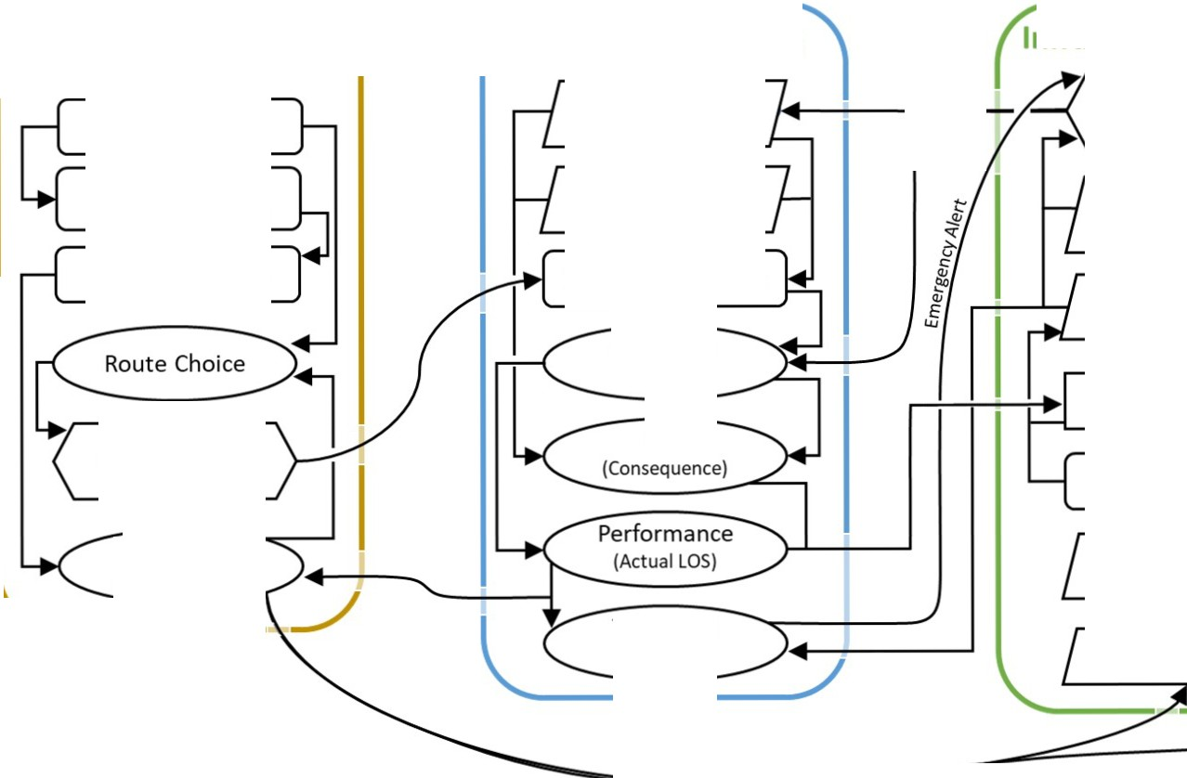

*1 1012 ) 45-5'1*

Introduction leads to why this model

INTRO

Home Intro_N_Background The_Model Virtual_Network Network_Demand Network_Owner_N_Management

•Problem statement



**Can we *model* the current state of TAM**

• **at the Local Municipalities (City Ownership)**

• **[via a Hybrid ABM]**

• **to Examine Potential Impacts to Livability, Sustainability, and Resilience**

• **Due to different Agency Type Scenarios:**

• **(1) Worst First vs.**

• **(2) Single Asset Optimization vs.**

• **(3) Network Optimization vs.**

• **(4) Multi-Objective Sociotechnical Optimization**

**…**

Home Intro_N_Background The_Model Virtual_Network Network_Demand Network_Owner_N_Management



Surface Transportation Funding Bills - MAP-21 and the FAST Acts

**Transportation Planning [1201 & 1202]**

• MAP-21 made a number of reforms to the metropolitan and statewide transportation planning processes, including incorporating performance goals, measures, and targets into the process of identifying needed transportation improvements and project selection. The FAST Act includes provisions to support and enhance these reforms. Public involvement remains a hallmark of the planning process.

**National Highway Performance Program [1106]**

• The FAST Act provides an estimated average of $23.3 billion per year for the NHPP, which will **support** the **condition** and **performance** of the National Highway System (NHS)

• Enable the construction of new facilities on the NHS

• E**nsure** that investments of Federal-aid funds in highway construction are directed to support progress toward achieving performance targets established in a State’s **asset management plan** for the NHS.

• The FAST Act also makes the following changes to NHPP eligibilities:

• It allows States to use NHPP funds for reconstruction, resurfacing, restoration, rehabilitation, or preservation of a non-NHS bridge if the bridge is on a Federal-aid highway.

• At a State’s request, the Secretary now may use a State’s NHPP apportionment to pay the subsidy and administrative costs for TIFIA credit assistance for an eligible project.

• It provides specific NHPP eligibility for vehicle-to-infrastructure (V2I)

communication equipment.

Recap – HComuerrIentrno_tN_SBatcakgtroeundofTAhef_Mfaodierl s Voirtfuali_nNetTworrak nNseptworkr_Dteamtainod nNAetwsorsk_eOtwner_N_Management



Management

1. While the **current** transportation infrastructure asset management plans analyze **assets as part of an inventory**, they **fall short in providing adequate** overall network level performance.

2. The **limited available transportation funds** are used to address critical short term concerns, while long-term cost savings and performance enhancement measures are push aside.

3. The **“worst first”** prioritization methodology can lead to unintended changes and greater

future expenditures:

4. The transportation network has many links **(interdependencies**) with other engineered and “natural” systems. This creates a **high level of complexity** within the network that is difficult to predict its future state.

5. Natural and man-made events, such as flooding or new development, can create **additional stresses** to the system. There is a demand that is not currently being met, at the local level, to be able to simulate these events and develop strategies to mitigate their effects.

6. States are likely to begin to put pressure on local municipalities to **comply** with the data collection and reporting standards required under MAP-21 and the FAST act. It is important to explore how these new requirements can be beneficial to the old way of business for the cash strapped local DOTs.

**National Highway Performance Program [1106]**

• The FAST Act provides an estimated average of $23.3 billion per year for the NHPP, which will **support** the **condition** and **performance** of the National Highway System (NHS)

• Enable the construction of new facilities on the NHS

• E**nsure** that investments of Federal-aid funds in highway construction are directed to support progress toward achieving performance targets established in a State’s  **asset management plan** for the NHS.

• The FAST Act also makes the following changes to NHPP eligibilities:

• It allows States to use NHPP funds for **reconstruction**, **resurfacing**, **restoration**,

**rehabilitation**, or **preservation** of a **non-NHS** bridge *if* the bridge is on a Federal-aid

highway.

• At a State’s request, the Secretary now may use a State’s NHPP apportionment to

pay the subsidy and administrative costs for TIFIA credit assistance for an eligible

project.

• It provides specific NHPP eligibility for vehicle-to-infrastructure (V2I)

communication equipment.

Asset Management- FHWA style

[**ASSET MANAGEMENT PLAN CONTEXT**](https://www.youtube.com/watch?v=cUXh-hYN6oM&amp;index=1&amp;list=PLhCPG3V68yV6-1gPGXmScnJl30gcxF96U&amp;t=777s)

[----------- -erhi-algb9llilitratlon](http://transportationfortomorrow.com/final_report/volume_3_html/technical_issues_papers/paperb571.htm?name=4i_03)

((The goal of infrastructure asset management is to meet a required level of service, in the most cost effective manner,through the management of assets for present and future customers."- NAMS

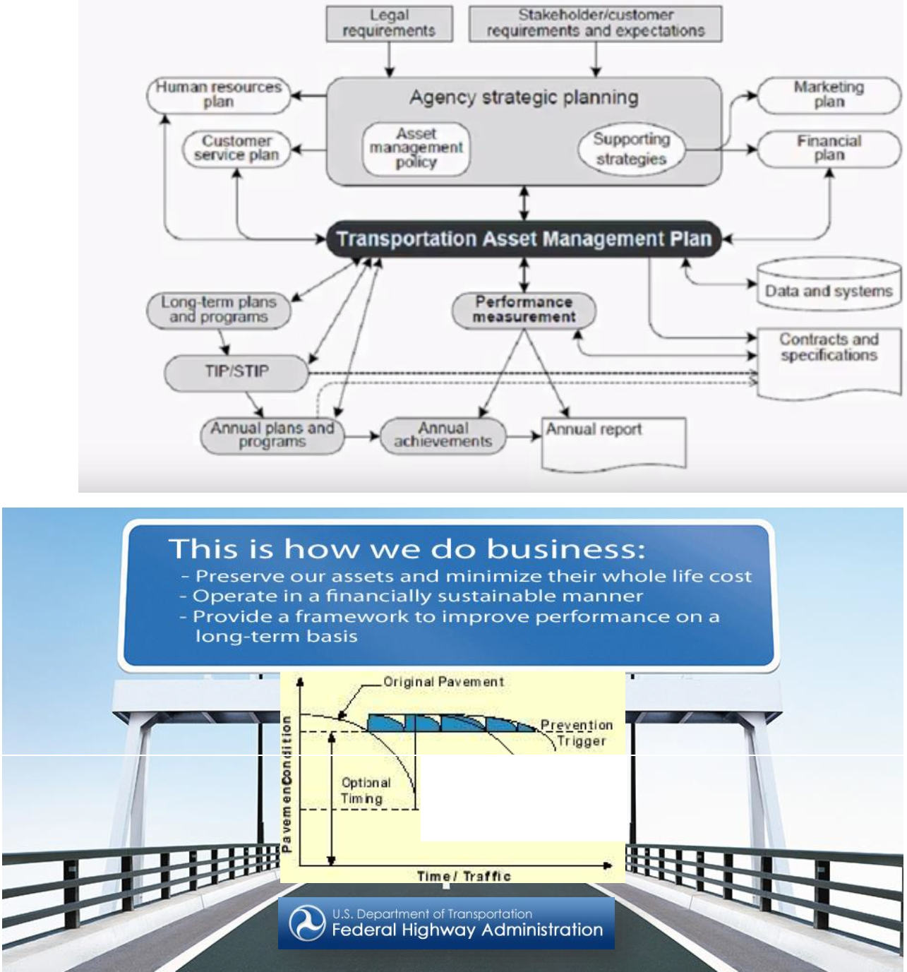

The systematic approach to the integrated management of the highway infrastructure to deliver agreed service levels at minimum whole-life value

Recognize that the revenue available for asset management is a significant constraint!

Home Intro_N_Background The_Model Virtual_Network Network_Demand Network_Owner_N_Management

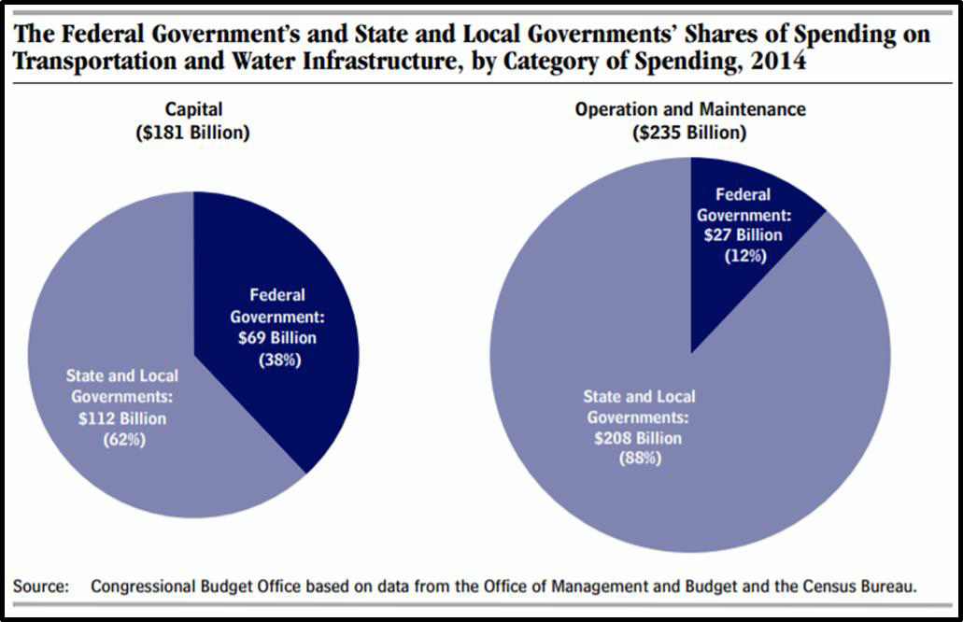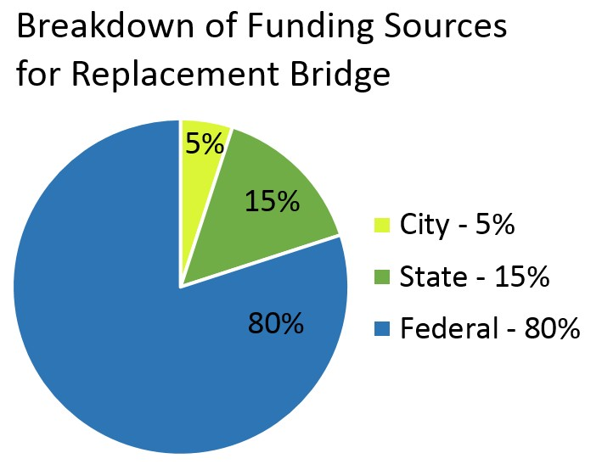

Challenge:

Fed Government can do more to encourage **Maintenance**

• Operations and Maintenance responsibility is assigned to State and Local Gov’s

- ***unless emergency retrofit or renewal is required.***

• The Federal Government has been changing the language included in Federal Transportation Bills since the 1980’s, but unfortunately there is still a wide gap in how funds are allocated between new vs preservation (FHWA 2015; PEW,

2015)

Home lntro_N_Background The_Model Virtuai_Network Network_Demand Network_Owner_N_Management

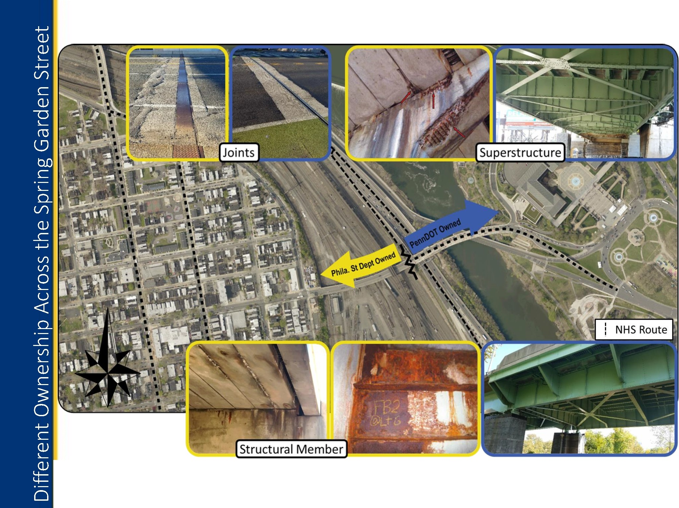

**Viaduct- State Segment Restored 2015**

Home Intro_N_Background The_Model Virtual_Network Network_Demand Network_Owner_N_Management

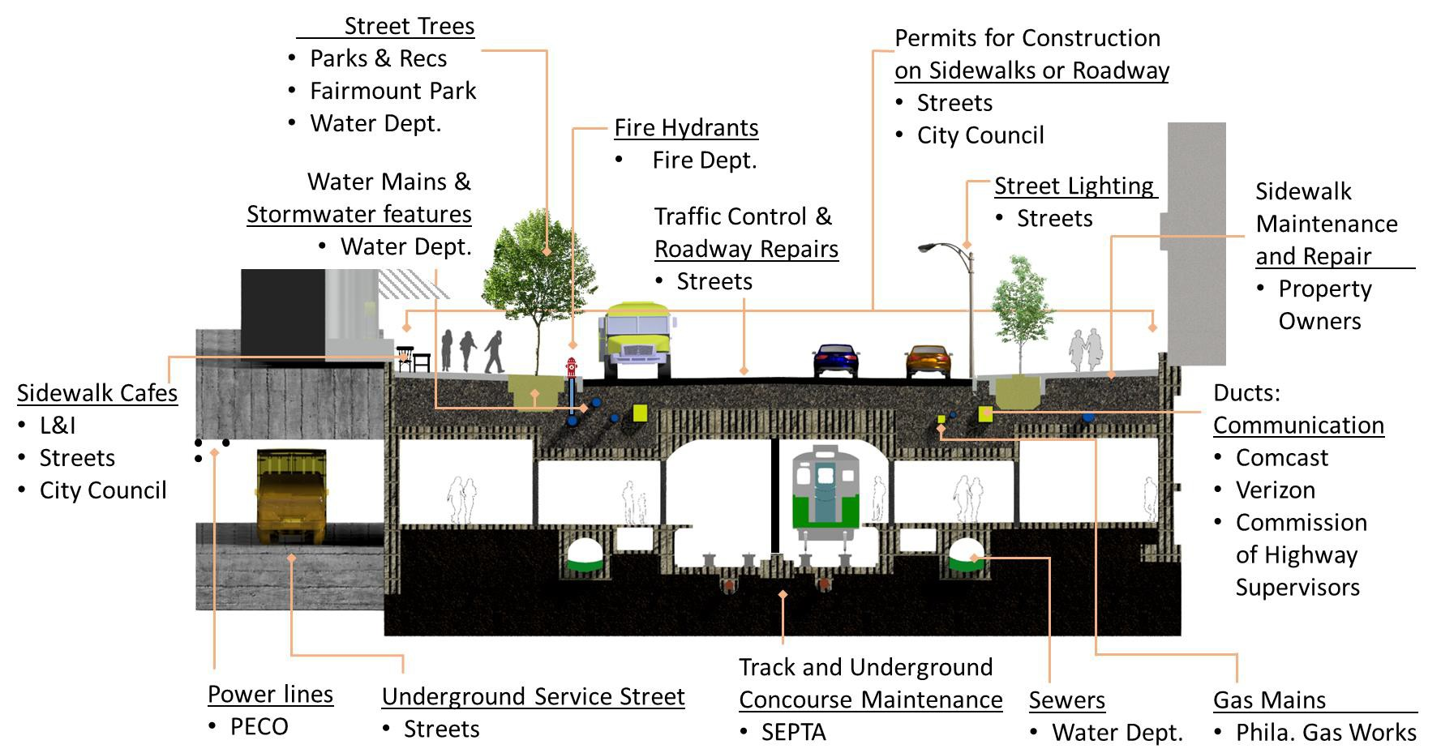

Challenge: Complete Care of a City Street

Cross-section of East Market Street with Assets and Responsible Steward

Ownership of

Philadelphia's Streets

7 – Government Agencies

2 - Quasi-governmental

agencies

4- Private Owners

1 – Local Law Making Entity

(PlanPhilly.com)

Home Intro_N_Background The_Model Virtual_Network Network_Demand Network_Owner_N_Management



A Way Forward

• Data driven policies and actions

• Pros:

• Transparency

• Lower Life Cycle Costs

• Performance Driven Outcomes

• …

• Cons:

• Large Initial Investments

• Agency Resistance to Change

• Sociotechnical Concerns

• Socially connected issues never have an optimal solution for everyone.

• How are priorities established?

• How do the trade-offs effect the multi-domain metrics?

• Political Election Cycles << Asset Life-Span

Problem Statement

Why this model helps at all?

Questions to be answered

Home Intro_N_Background The_Model Virtual_Network Network_Demand Network_Owner_N_Management



Questions to be answered by Scenarios

~~1. What are the impacts of~~ **~~New Development~~** ~~to the immediate surrounding~~

~~roads and the overall performance of the network?~~

~~•~~ **~~Set up:~~** ~~Increase demand in a local area~~

~~•~~ **~~Assessment~~** ~~- Changes In: User Travel-Times and User Experienced Level of Service (ELOS); Asset~~ ~~and Network Performance; Asset Life-Cycle Costs (LCC); Maintenance Activities~~

~~2. How should~~ **~~assets be prioritized for resilience~~** ~~retrofitting to reduce the~~ ~~impact from extreme weather events? (~~**~~Flooding)~~**

~~•~~ **~~Set up:~~** ~~Remove roadways that are within the 500 year flood plane;~~

~~•~~ **~~Assessment~~** ~~- Changes in traffic patterns; Identify, with multi-objective criteria, critical assets which~~ ~~should be prioritized to ensure maximize network flow and connectivity;~~

3. How can the **scheduling of maintenance and construction activities** impact the immediate surrounding roads and the overall performance of the network?

• **Set up: Construction Delays** – Active road work = road/lane closure; Milled road surface = reduced condition levels to impact max travel speed

• **Assessment**: Under different scheduling methodologies (ad-hoc; asset focused optimization; network focused optimization; socio-technical optimization) – what are the different impacts to Travel-Times and ELOS; Asset and Network Performance; Asset Life-Cycle Costs; Maintenance Activities

4. How does the **variability of future funding** effect the management decisions and LCCs?

• **Set up:** During long term planning routine increased or decreased the **variability** of the next year’s **budget**. Budget amount and variability will be based on the financing mechanisms available to the owner

• **Assessment**: Are there changes in spending patterns? Are their any significant efficiency gains between different financing structures?

5. Is there a significant impact from **data collection and utilization methods** to the network’s performance, ELOS, and owner operational behavior?

• **Set up:** Conduct a sensitivity analysis of the owner agent’s **data accuracy** (possibility of reporting no change in condition)**, resolution** (how many attributes of each asset are collected; linked to model sophistication)**, and update frequency** (how often is the data refreshed)**,** and **predication model sophistication** (regional models, simple linear regression model (local data)

• **Assessment:** Are there significant changes to the network’s performance, ELOS, and owner operational behavior?

Home Intro_N_Background The_Model Virtual_Network Network_Demand Network_Owner_N_Management



Recap – Deliverables

• Create an ABM of the management of transportation assets in a segment of Philadelphia to assess how the different TAMP factors effect the life-cycle cost of the assets, network performance, and users’ experiences.

• The model must have the **ability** to:

• Simulate of user behavior – variable driving parameters, rerouting capabilities,

• Capture users’ experience – level of service received from assets per user

• Simulate the deterioration of roadway conditions and have the conditions effect

the users’ experience

• *Max Speed* a function of *condition*

• *Condition* a function of [*equivalent single axle load ESAL*](http://www.pavementinteractive.org/equivalent-single-axle-load/) and possibly geographical location if the proper models can be found

• Closeable lanes to simulate road work

• Vary starting parameters to mimic **actual condition of existing network** and to simulate **disruptions caused by natural disasters**

• Simulate **System Level Transportation Asset Management Decision Processes** with

Owner Agent Framework

• Owner agents must be able to develop an action plan based on a variety of inputs and constraints

• Roadway condition data; traffic jams; accidents; predicted future needs; political pressure; Threshold Triggered Actions

• Multi-variate system performance metrics to base optimization

• Individual Asset and Network Cost minimizing; Network Performance

Maximization; Maximize User Experience

• Capture Sociotechnical and Engineering Interdependencies

• Random disruptions (closures, drop in condition rate, etc. related to non-owner related construction work)

• Link roadway condition and time lose to user experience

• Link user experience to political component of prioritization of maintenance work done to an asset

Others for now

Other papers or projects similar

Literature Review

*Papers By Topic*

ABM and Hybrid Models

Home Intro_N_Background The_Model Virtual_Network Network_Demand Network_Owner_N_Management

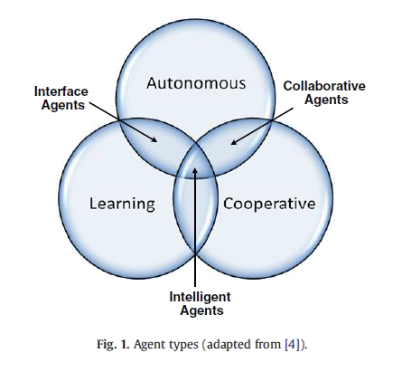

What is Agent Based Modeling?

• An agent based model (ABM) utilizes a bottom up approach to define the rules of behavior and interactions for different actors/individuals within a complex adaptable system. The purpose is to simulate the “agents” interactions to observe and study the resulting emergent behavior.

• Agents can be thought as an individual software packet that through its interactions with its environment and other agents

• Even with simple rules of behavior, complex non-determinate systems can be modeled

• Agents typically have **three basic functionalities**, the ability to operate **autonomously**, **cooperatively**, and **learn** from their encounters. An *intelligent agent* has all three capabilities (Osman, H. 2012).

• This model will contain many different dynamic components, but the **owners**, and potentially

**elected officials**, will be the ***only*** *true intelligent agent*

• The other components being the **users** and **infrastructure assets** have dynamic behavior and

**respond** to their environment and interactions

• **User’s** operate in a cooperative manner. By sharing re-routing information with the network.

• **Assets** will deteriorate based on their geographical location and simulated use

Agent Types *(Osman, H 2012)*

Home Intro_N_Background The_Model Virtual_Network Network_Demand Network_Owner_N_Management

[DropBox\PhD\Papers](https://www.dropbox.com/sh/sa5lb2bxzjkyymf/AAAwn3quLdFmQ_idEi6LXq0Ea?dl=0)..

|  |  |
| --- | --- |
| <DIR> | Abstracts |
| <DIR> | AM Related |
| <DIR> | Asset Management for ranking |
| <DIR> | Bibilos |
| <DIR> | BMSs |
| <DIR> | Bridge Maintenance |
| <DIR> | Coding |
| <DIR> | Complexity |
| <DIR> | Conferences |
| <DIR> | Coordination |
| <DIR> | Cross Sector |
| <DIR> | Database objects |
| <DIR> | Decison Factors |
| <DIR> | Design |
| <DIR> | Deterioration |
| <DIR> | Disertation Examples |
| <DIR> | Education |
| <DIR> | FHWA |
| DIR> | IEEE |
| <DIR> | Images for Paper |
| <DIR> | Infrastructure |
| <DIR> | Life Cycle Assessment |
| <DIR> | Liveability |
| <DIR> | Markovian Informatin |
| <DIR> | Modeling |
| <DIR> | NSF |
| <DIR> | NSF FD LB 2 |
| <DIR> | Organizational Structures |
| <DIR> | Performance |
| <DIR> | PHMS |
| <DIR> | Read these then sort |
| <DIR> | Reference Manuals |
| <DIR> | Regulations |
| <DIR> | Roads |
| <DIR> | Sociotechnical Approach |
| <DIR> | TAMPs |
| <DIR> | to be read |
| <DIR> | Transportation |
| <DIR> | Transportation and Economics |
| <DIR> | TRB |

Home Intro_N_Background The_Model Virtual_Network Network_Demand Network_Owner_N_Management

Network Demand Virtual Network Agent

**Legend**

**SUMO Drivers**

Type

Characteristics / Rules of behavior

LOS Expectations

Route Choice

Consume/Use

***Level of***

***Satisfaction***

**Infrastructure Asset**

Physical

Attributes

Environmental

Attributes

Deterioration Rate

Condition

Rating

Risk

(Consequence)

Performance

(Actual LOS)

Threshold

(Priority)

modifies

**Infrastructure Owners**

Maintenance

Activity

TAMP Activity

Schedule

Action Trigger

Policy

Objectives

Risk Tolerance

Organizational

Constraints

Budget

Static Parameter

Time Dependent

Parameter

Action & Time

Dependent Parameter

ACTION

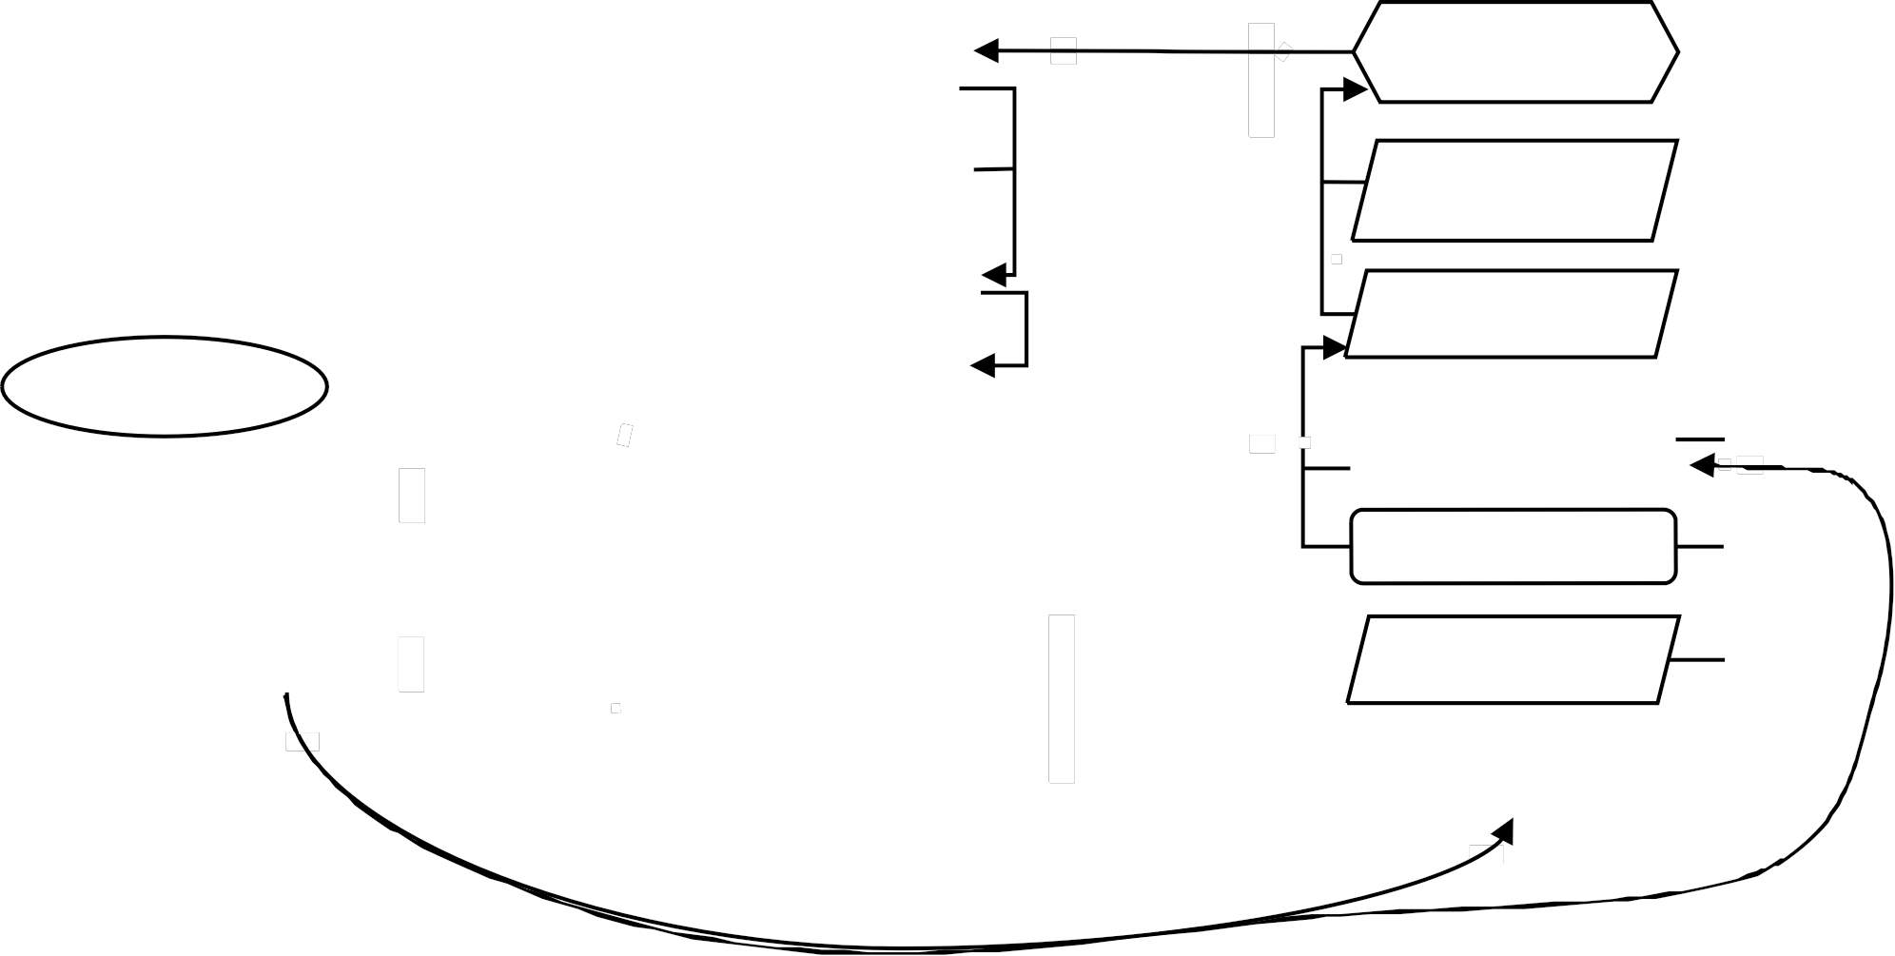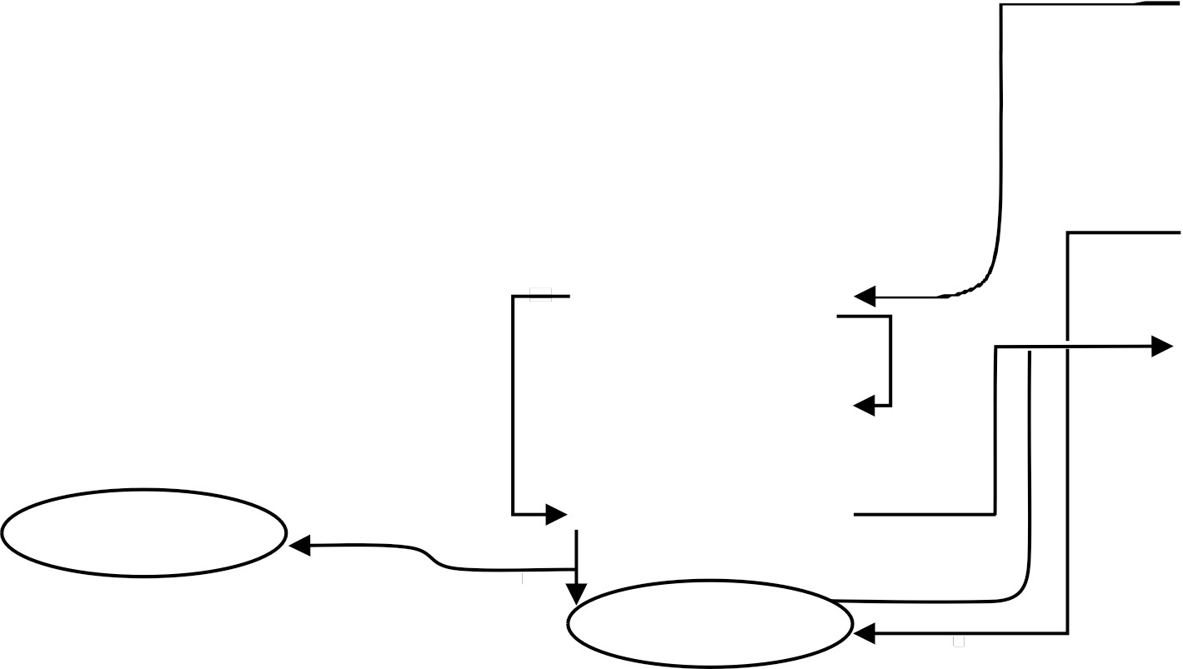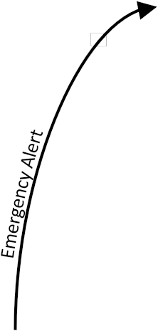

Relationship Visualization concept from:

[H. Osman / Automation in Construction 28 (2012) 45-57](https://www.dropbox.com/s/3ztli6rqtvvh98u/Agent-based%20simulation%20of%20urban%20infrastructure%20asset%20management%20activities%20-%202012%20-%20Hesham%20Osman.pdf?dl=0)

Home Intro_N_Background The_Model Virtual_Network Network_Demand Network_Owner_N_Management



What does a Complete Model Look Like

• OSM base map of segment of Philadelphia’s Fairmount Park

• Traffic – vehicles per hour and vehicle type distributions

• Based on DVRPC available traffic count data

• Routes – based on heuristics

• Deterioration based on the ESAL of the simulated traffic and random events

• Need to find a way to incorporate environmental factors for individualized decoration

rates

• Compare predicted damage (no interventions), based input date, to simulated damage. This will be a critical test to see if SUMO is worth the time and effort.

• Owner agent module

• Creates work plan schedule to meet predefined goals

• Random; Worst First; Corridor; Isolated Asset Group; Combined Asset Management; Service

Provided; Multi-Objective Optimization

• Constraints: Budget; Politics (geospatial distribution); Organizational

• During simulation owner carries out schedule work or reacts to emergency events

Home Intro_N_Background The_Model Virtual_Network Network_Demand Network_Owner_N_Management



How is the Simulation Validated?

As with other simulations and models the quality and accuracy of the

input data plays a significant factor in the accuracy of the output.

• The topology of the network is imported via data from the

[OpenStreetMap](http://www.openstreetmap.org/export%23map%3D13/39.9623/-75.2103) database.

• Creating realistic demands to flow across the network is a great deal more complicated.

• ***DVRPC’s House Hold Trip Survey Data*** is used to generate trips within the

network.

• ***DVRPC’s Traffic Count Data*** is used during the simulation to either increase or decrease the traffic volume to match the historic records

•  **Number of traffic count locations in the AOI = 38**

• ***DVRPC’s Vehicle Class Data*** is used to determine the vehicle type distribution in the simulation

•  **Number of Vehicle Class count locations in the AOI = 3**

• This data is integrated together to create a defined number of vehicles per hour passing over known streets. The traffic simulator’s *Calibrator* element reads this information and tries to add or remove vehicles to the network to match the defined flow.

• Other parameters such as turning permissions and traffic signal timing, can also be adjusted to match defined flows and field measurements.

Home Intro_N_Background The_Model Virtual_Network Network_Demand Network_Owner_N_Management



Potential Impacts

• The research model will not be 100% accuracy.

• Goal use hard data and validated rules of behavior to validate the simulation with real life

• Simulation must be run many times for patterns of **emergent beh**avior to

be established.

• Running the simulations under **different management principle objects** and **agency constraints** we will be able to analyze how the **small local changes can impact the greater network and performance**

• DVRPC – Has the tools and resources to continue building on their existing Transportation Improvement Models (TIM) to incorporate sociotechnical components to further the mission of improving the Livability, Sustainability, and Resilience of the region.

Home lntro_N_Background

The_Model Virtual_Network Network_Demand Network_Owner_N_Management

.......................................................

0

!)dmary f unrtlnn

...-.

• t: '- ' Rf'J'I'btl-

• IM iri iMr ..,...if

0,---

..

:0

: Transportation Prlmaa Funclinnot

Comnonen (i

....-

• .t,.....-,.,...._Oprr.t.en'dfrioi.m

,.,.._...,&hb•lrl') llltatl•

Society

IYM"rlAgents

u

itt Uti t t Uti

lrl Allrihutt

• lwriO

Primarv Functions

•Counmt

infraslructurt senlees

•Soclol«hniul

Trip Definitoi ns (per user:Node_i to Nodej

. : ::r:;:::: ;:;::,:':..:;

1=.' ::::'.:::::............

~~B~~

. ,Mf•d;na!)d lam

Nf'lwork AUributcs

·\tdt••lll 81111hom

. , '"'•"nm'"'

• Ia:!lit.IJ&l!l.SI..Si&no.I'YW!IIn

• .,.,....- d tl[frntef!• M

•10.\la• ·'-""''..W.'-\«t•.

• s.t&d 4Nr,.,_.;.•Y"'• -LM•l.Slatc-,••frot-nol

• fHtl'-tk _la,..l••"- IJS[IItS'alllb

• Rt-1••"-"-l'l•l"l lui-'-

• \ ,.-1\..,f\dMd \ WI\.N p js ln1>iL ll:fn!..dl.lll

. n.".......,.,...

' l....lt t«.'f"4t MMO,d•

• l wr Orl ria tdf ! W I)rulaatl011 !!k J

·

• llwntW..tlnwl_.._..'-

. ......,.,..,., ..,,rilpw!t.

• T ntl'k1r.rucn-

_

• J-1k1M....M.I....·. "Ill •flaltleM

•A•·allablorO..tptlb

. filtl:duUI.J..d.!.l:l...,...-.........................-

.....

wtm•l... \e!so·-·aa·.- ..,.....,......_loff

Prln1arvu,n. cllnn

• Sf!Ht., k.I'MII"ft-M

l t,a.«aM"IM'II.

• Opt.Ut tobjtctht f-ro.

bJoW •Ir.-llo!

rf'Cth'Hb) m1-.wb

:..t.!.l.e..t.i,l.t.-..•.f.w.......o..lar,

-

Hw­

........._

:......

Owner sub-attributes

A.Building vehicle routes from derNnd definitions B.Computint routes duril"'l a user assignn'H!nt C.Repairlna connectivity problems In e. lsttnc route files Adv; nced Routing Types:

lnttrmodal RoutlnR

From Ongm/De}mtatton Su rveyt

Actooty Btwd Ofmand GfneriJ!()f)

,-"'-""' "!e'-el•

Replacement Optimization Algorithm:1" Attempt

*Ob{(ctlv( Function :*

*Min Ln; Repair edgeN(1,0)@yearr* • *Repair _Cost@yearr*

Ootrator Allrlhute'

• \laiM...,.-<t'Sir.ff1:in

• DKI•._Opt-.-C..e1

........ ..

·\•1tllal:lk l.t:......_

• l"ritorltll:art.. f'IC'Ien

l.lt iM • e lk U•iw

('

• \..l.t-alla- ala ...-..••PCR

\lriii(W)

•h)t f4cri Htr-a.ltkptMtrno.pritft

--,-

-

,.....,,....,..._... .._..............

-

:_=..- --

rq _ .........,._ ..... _

Where the repair_edgva; riable is binomial.

*Subject to:*

Time sincelast repair less than or equalto 15 years

(TSLR) S 15 yrs

The percent condition rating as a function of TSLR must be greater or equal to

50

11'1 .................,_----,..._.-" .....................,_

............... ·-· ,1....1'1-..,..,..,...........

.._ , .._ _.,......._.....--...

- -· . .

-''-+.:::_::

PCR(TSLR) 50

TotalCosts cannot exceed budget

I*N*

=.-...-....=-=-:=-=-= -,o..:.:,=-..-..=...-..=......t.:...:.:-:.o..:....:..:.:.-:.-.- -

=- -=.,.~~......~~

....

...

*Repair_edgeN( t,O )@yearr* • *Repair cost@yearr* :S *Budget*

I

Average condti ion rating must be greater or equal to 70

*L*

T- ,._,.....Otlll-_•__,..,=,---- -

*._::-,.* ,-a

.... --.............. Sf)t • •

---.,"*-.a..-..-.,-.- .U. ..-:n-

*N*

*PCR _edgeN/(N* • 90) <: 70

I

......... .............. ,........ $

-cJ.M.....o,.-.· C-I'....-,._.,_,-. I.1..S,

r-..1.

n-•

The issue that Iam having is that once the repair is chosen the TSLR has to be



reset.Such that TSLR(i)= (TSLR(i-1)' (Repair_edge ) +1

file:///C:Nsers/Biko;Oropbox/PhD/Papers;Oeter ioration/Research9620of9620Cur rent962CPractices96 20in9620Pavement962CPerformance962CModeling3620·96 20PennDOT.pdf

C:\Users\Biko\Dropbox\Asset_Management\Proposai\Simplistic modeling *cf* lAM of tJban area scriptdocx

--c- .,_

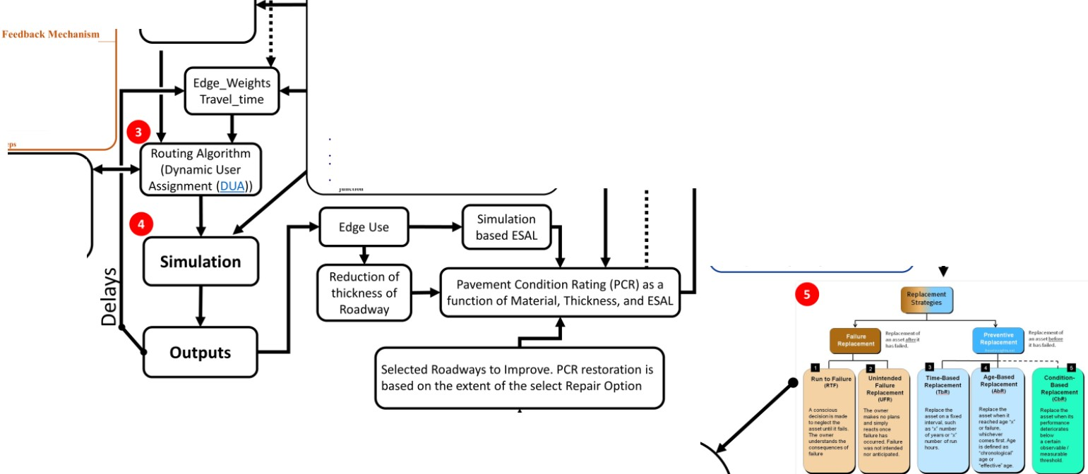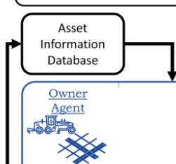

Home lntro_N_Background The_Model Virtual_Network

Network_Demand Network_Owner_N_Management

0

!)dmary funrtlnn'l

...-.

0,---

..

.......................................................

:0

: Transportation Prlmaa Funclinnot

Comnnnen(li

....-

• t: fer« Rf'J'I'btl-

' MiriiM..,...it

• l.tft"''-.,... ..prr. ..,df rioi.m

,.,.._...,&hb•l rl') llonll•

Society

IYM"rlAgents

u

itt Uti t t Uti

llt r Allrihult

• lwriO

Primarv Functions

•Conumt'

infraslructurt senlees

•Soclol«hniul

Trip Definitions (per user:Node_i to Nodej

. ::r:;:::: ;:;::,:':..:;

-. =::::'.:::::............

~~B~~

. ,Mf•d;na!)dlam

Nf'lwork AUributcs

·\tdt••lll81111hom

·, '"'•"nmiM1

• Ia:!lit.IJ&l!l.St..SA&n., I'Y W! In

• .,.,....,-,dtl[frptef i•M

•10. \1•· ·'-""''..W.'-\«t•.

• s.t&d 4Nr,.,_.;.•Y"'•-LM•l.Slalc-,,_. frot-nol

• fHtl'-tk _la,..l••"- IJS[IItS'alllb

• Rt-1••"-"-l'l•l"l lui-'-

• \ ,.-1\..,f\dMd \!WI\.N p js ln1>iL ll:fn!..dl.lll

. n.".......,.,...

' l....lt t«.'f"4 t Mten..

•-lwrOrlri•'tdf IWI)rulut!OII'!!k J

• llwntW..tlnwl_.._..'-

• lllt:"fldo!HIItrilpw!t.

• Tntl'k1r.rucn-

• J- tkiMIINI M.I...... "Ill• fleltleM

• A•-•II!blorO..tptlb

_.....,..,...,...,,..........

. f"ilt'l:"du'"U..t.J,d.!l.:l ......_. ...................,. .....,......_loff

,..._,..._•fw..ollr, ~~.~~..........,......,.................

-

Prln1arvu,n. cllon\0

•SfiHtl•doi'MII"ff-al

t•"f'la«•M"IM-11.

'Opt.Ut tobjKti\t f-ro..

bJoW •Ir...tlo!

l'f'Cth"Hb) m11»fb

Owner sub-attributes

A.Building vehicle routes from derNnd definitions B.Computint routes durirc a user assignn'H!nt C.Repalrlna connectivity problems In e. lsttnc route files

lnttrmodal RoutlnR

;

Hw-

, .t dwet...t. ll'-.t•

Ootrator Allrlhut

• \laiM.-..Ht!itr.ff1:in

• DKI, ..Opt._...tC..e1

l.ltl.l..lt.•...t.k.U.•i.w

Adv;nced Routing Types:

.,...... ...

• l'ritorltll:ert.. f'M'Ien

al t:.........

From Ongm/De}mtatton Surveyt

Actooty Btwd Ofmand GfnefiJ!()f)

('

• \lal..t-111 •- eta IIIIi--•• P'Ck

\ltlll(lr)

•l'a)l f4ct'UH1r-eftkptMttnl.. pritft

Replacement Optimization Algorithm:1" Attempt

*Ob{( ctlv( Function :*

*Min Ln; Repair edgeN(1,0)@yearr* • *Repair _Cost@yearr*

- _ f'QI ,-

._ .........,._ ..... _

Where the repair_edgva; riable is binomial.

11'1 ...............,_----,.._.-" .....................,_

*Subject to:*

,.....,,....,.._...

._..............

Time sincelast repair less than or equalto 15 years

(TSLR) S 15 yrs

The percent condition rating as a function of TSLR must be greater or equal to

50

.............. ·-· ,1...1. '1-..,..,..,...........

.._...,._. , .._ _.,......._.....--...

___...._

- -· . .

-''-+.::_::::_=..- --

PCR(T5LR) 50

TotalCosts cannot exceed budget

=.......==-:=-== -..o..:.:=.=...-.=...-..=.....t.:.:::.o..:....:.:.-:.-.- -

• w_x:1 _,rr. ........

*N*

*pair_edgeN( t,O )@yearr* • *Repair cost@yearr* :S *Budget*

I

--· - -...

...-

,..,=,----- -

I

h"trrtor).:tt.11t;('r'lrr.11trrl

*Re* =-T- ,._,.....Otltl-=.,.~~......~~ -_'

'" Average condition rating must be greater or equal to 70

*._::-,.* ,-a

--

*L*

I

........ .... --.............. Sf)t • •

_....,--.......a..-..-.,-.- sUo ..-:n-

*N*

*PCR _edgeN / (N* • 90) <: 70

......... ...............

,.....$..6..1 r-..

c-.......,.-.

--.-t ...,

Theissue that Iam havni g is that once the repair is chosen the TSLR has to be

reset.Such that TSLR(i(= (TSLR(-i 1)' (Repair_edge ) +1

JMo·c........-.,_ r-. 11.s n-•

--c- .,_



file:///C:Nsers/Biko;Oropbox/PhD/Papers;t)eter ioration/Research9620of9620Cur rent962CPractlces96 20in9620Pavement962CPerformance962CModeling3620·96 20PennDOT.pdf

C:\Users\Biko\Dropbox\Asset_Mar.agement\Proposai\Simplis tic modeling *cf* lAM of t.rban area scriptdocx

Home lntro_N_Background The_Model Virtuai_Network Network_Demand Network_Owner_N_Management



DVRPC Vehicle Class Data Generated Probabilistic vehicle type distribution

Car Following Model Parameters

**SUMO­**



**Higher Level Detailed Full**

**Simulation Flow Chart**

Population Generation

• DVRPC House Hold Survey

Data Generated Trips

**Simulation**

• Asset metric data points

• Asset performance

• Asset condition

• User Level Data

• Time lost

• Individual experience • Performance

• Risk

• DVRPC Traffic Flow Detector Data Generated Trips

Initial and Current ConditionsP---.

Material and Structure type Deterioration Rate Environmental Factors Actual traffic use

Asset Information is updated per schedule of Actual new asset condition are activities to reflect *work zone lane closures* probability based on owner

and other network parameters that are

*effected by the activity* agent qual ty control polici es

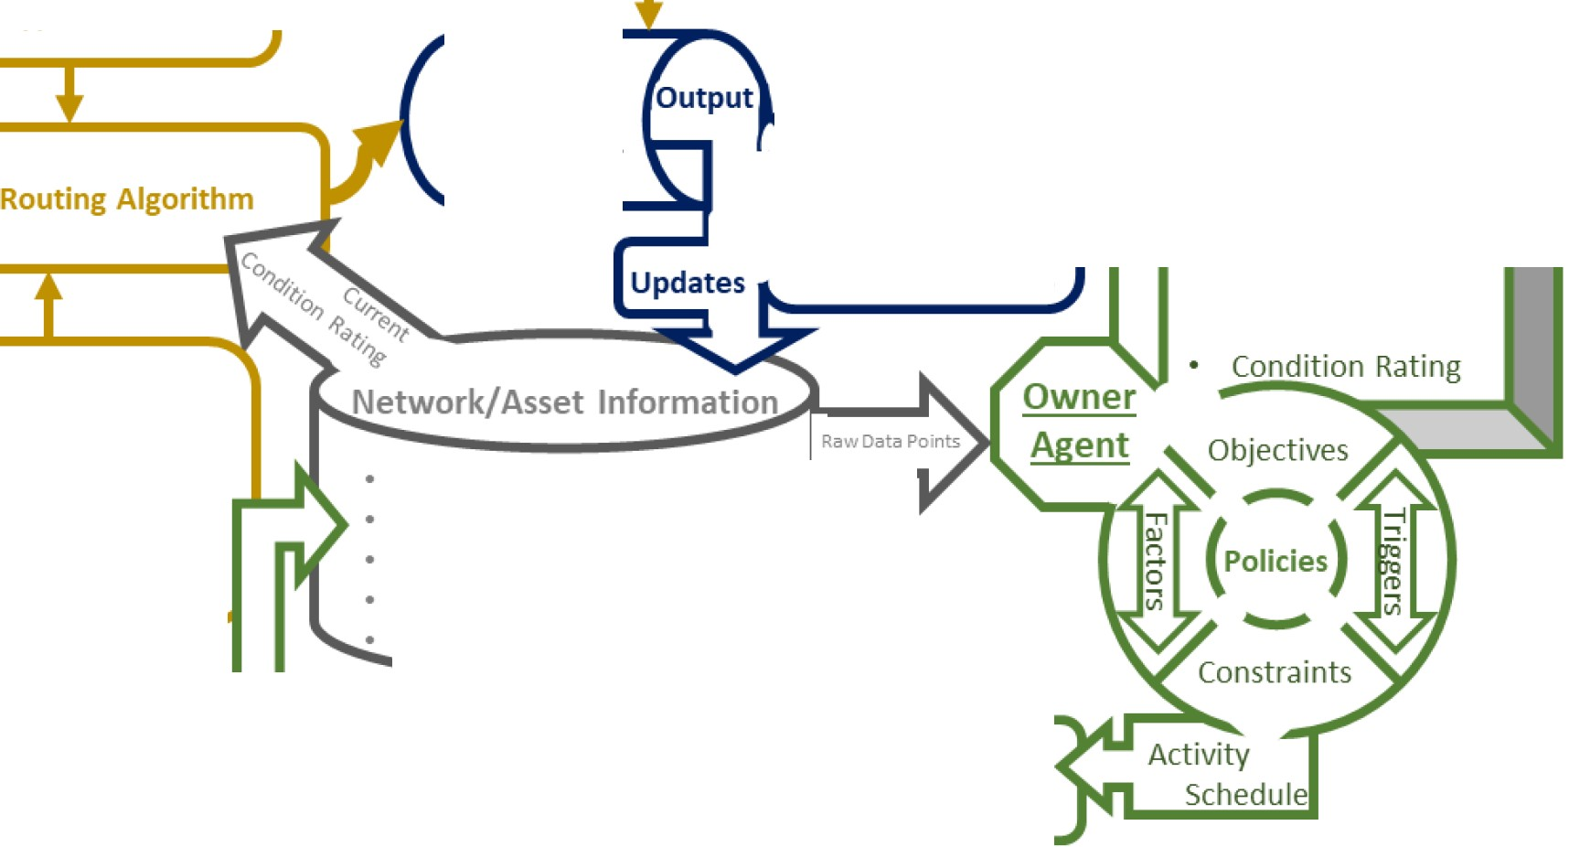

Home Intro_N_Background The_Model Virtual_Network Network_Demand Network_Owner_N_Management



Model - Limitations

• Trying to simulate a “wicked problem” is inherently inaccurate.

• There is no “right” answer to how much detail and complexity needs

to be modeled to create a simulation with meaningful results.

• I will rely on assumptions and randomness to simulate the interactions

between the different systems

• Human → Human, Human → Engineered, Engineered → Human, Engineered → Engineered, Natural → Engineered

• The output of a single simulation is not meaningful. It will take possible thousands of simulations runs for any discernable emergent behavior patterns that can be used to draw conclusions.

• A single day can take many hours to simulate, this will limit the amount of scenarios and permutations of

individual scenarios.

• Travel patterns within the network are calibrated by traffic count data that is only a snapshot (3 days) in time

• There are many factors that lead to the deterioration of an asset, this research will only account for use, weight of vehicle, sun exposure, and pavement structural composition.

• I am still searching for a more sophisticated pavement deterioration model.

• Limited amount of historic and current condition data, unknown accuracy of data

Home Intro_N_Background The_Model Virtual_Network Network_Demand Network_Owner_N_Management



Components of the Simulation

• Graph model of physical network topology – Deterministic and

Probabilistic

• How many lanes are on each street (edge)? Where as the intersections (nodes) between

the length of the street? - Deterministic

• Control Systems

• What are the control parameters at the different intersections – Traffic Lights (phase timing), Stop

Signs, Merging, etc. - Deterministic

• Lane designations and permissions – Turning lanes, Bus Lanes, target lanes at junctions -

Deterministic

• Speed Limits - Deterministic

• Pavement deterioration rate – Statistical and Probabilistic

• Based on FHWA Pavement Deterioration Models and simulated use

• Network Use – Statistical and Probabilistic

• User – [Car Following Model](http://sumo.dlr.de/wiki/Car-Following-Models) – Vehicle type differences: accelerations, decelerations,

deviation from speed limit, driver imperfection, etc - Probabilistic

• Demand – Trips: Who, From, To, When, How?

• DVRPC – House Hold Trip Survey Data ~1,700 unique trips - Deterministic

• DVRPC – Traffic count data - Statistical

• Validation of new trips and data – Statistical

• Matching output trends to known traffic patterns - Statistical and Probabilistic

• Calibrator tool (adds or removes traffic during the simulation to match count data) - Probabilistic

• Simulation – Users + Trips + Network + Control Systems – *Network*

*Performance is Non-Deterministic*

• How were the different assets used? – Current Pavement Condition Rating

• How did the network of assets effect the user?

• User delayed in jam? User involved in an accident? User arrives significantly later at destination than expected?

• Transportation Agency Decision Simulator- Statistical and

Probabilistic, but Simulated Emergent Behavior is Non-Deterministic

Home Intro_N_Background The_Model Virtual_Network Network_Demand Network_Owner_N_Management

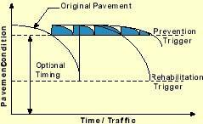

Owner Agent – Tentative Rules of Behavior

**Owner Agent** – Rules of behavior are Statistical and Probabilistic, but Simulated

Emergent Behavior is Non-Deterministic

• Following the FHWA TAMP workplan ([2013](https://www.fhwa.dot.gov/asset/tamp/workplan.pdf)) and the new [FAST Act Rules](https://www.dropbox.com/s/two8hhlsyc6u1te/National%20Performance%20Management%20Measures%3B%20Assessing%20Pavement%20Condition%20for%20the%20National%20Highway%20Performance%20Program%20and%20Bridge%20Condition%20for%20the%20National%20Highway%20Performance%20Program%20-%20FHWA%20-%202017.pdf?dl=0)

• Generates a schedule of work orders to be completed during the simulation

• Components of **Operation Research** optimizing objective function with

constraints, based on scenario

• Owner agent receives information about the transportation assets

• Owner types will differ through their optimization parameters, objectives,

and constraints

• Building and modifying short and long term plans based on non-

deterministic simulation network performance.

• Data is processed through different metrics and models to help

build or modify agency TAMP

• Owner agent’s make Transportation Asset Management decisions that

directly effect the virtual network

• Simulations permits the opportunity to observe the  *consequences* (good or bad) of different management policies and variations in finical and logistical parameters. – Deterministic and Statistical model parameters, but non- deterministic long term behavior

Virtual Network

Description of virtual network

Why SUMO

Home Intro_N_Background The_Model Virtual_Network Network_Demand Network_Owner_N_Management

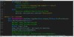

Why SUMO?

My final model will consist of two parts, a traffic simulator and an owner/operator module.

The open source software platform, “**S**imulation of **U**rban **MO**bility” (SUMO), will be utilized to simulate the traffic flows. Building off the existing source code, the simulator will collect and update critical information about the type of road, its age, its use, and its condition rating.

•

The owner and operator module will be developed as a standalone Python based module. The goal of the owner and operator module is to mimic actual maintenance and operational decision processes. The framework from the model will be based on FHWA’s transportation asset management plan (TAMP) best practices guidelines.

•

Home Intro_N_Background The_Model Virtual_Network Network_Demand Network_Owner_N_Management

SUMO vs PT VISUM

SUMO vs PT Visum

**Similarities**



• Each can interface with external Python Code during the simulation.

• Can use matrix O/D for demand

• Can import external files to generate points of interest (POIs)

• Uses traffic analysis zones (TAZ)

for routing purposes

• Abilities to model multi-modal transportation systems, transportation objects, and user classes

**Differences**

• SUMO is an Open Source.

Visum is a Professional

Software Package.

• Open source lends itself to incorporating new rules and behaviors into simulation easier.

• SUMO tools are natively written in C++ and Python; adaptation

of existing tools is easily

accomplished.

• SUMO has a wide community

of developers creating new tools and improving old tools.

• Visum’s add-on Market Place is limited, but contains a more sophisticated traffic engineering modules for modeling the TLS and roadway parameters.



**fhfOUih/**

**lhtNn Suburban ltilhl l&of1 Tum AaPept**

Table 5: Urban Road Free-Flow Speed

URBAN ROAD Measurement Loutlons Sample Soze



15

1.650

·-lfl_l

_ _

tl 92 tl

93 "

Base Speed 25

- .. Ill

Medoan Speed

-111_1

....,ft.l

20 20 20

J J J

Jl )J JO

""

20 20

33 *Jl*

an -----------------­ -6.•

•7.5

Urban Road

274

90 56

I'C. JOU

Sth Percentole Speed

20th Percentile Speed



-13.0

·11.0

**The results are presented in Table 8 below.**

Table1: Urban Road 5lcnol Throulftput Results

**URBAN Left ThrouJh**

Mean (seconds/vehicle/lane) 2 21 3.07

"'"""'"'"' ,.._,

I 2S 1.19

**Mu1um (seconds/veh•cle/bne)** 340 7.17

8Sth Percentole (seconch/-/lant) 2.67 3.93

**15th Percentile (seconds/vehicle/lane)** 1.7S 2.21

Number of Obsofvotlons 6S lOS

Standard Deviation 048 1.07

**Measuremt Locattont** 3 s

DVIIPC. 2012

lOth Pe<centole Speed

85th Percentole Speed

95th Pe<centole Speed Standard Devoatoon.: speed •m/h

Table 10: Rollins Stop Results



-.......

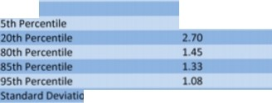

219

200 l90

-3.0

-1.0

3.0

6.29

OVRPC, 2012

17

456

• 67

Sll

**2.62**

l79

70S

772

9Sl

"------ '---- ·II

**DYRPC., 2012**

Home Intro_N_Background The_Model Virtual_Network Network_Demand Network_Owner_N_Management



Dynamic Network Analysis & Real-time Traffic

Management for Philadelphia Metropolitan Area

Final Report 2016 - Carnegie Mellon & PennDOT - <http://weima171.com/docs/WO004_final.pdf>

**Executive Summary**

This project developed a general regional network model to estimate/predict time-varying traffic evolution on all highways and major arterials in Philadelphia Metropolitan Region. A case study was conducted for assessing the dynamic traffic impact of road closures on freeways and/or major arterials in the Philadelphia Region; and propose real-time traffic detour plans as a way of using travel demand management (TDM) strategies to mitigate overall impact caused by closures

…The historical O-D demand data was also obtained from DVRPC in the format of VISUM. The O-D matrix is represented by a 3399 × 3399 matrix and in float precision. DVRPC also provided a main O-D pairs profile, which contains 10,000 main O-Ds. O-D connectors are also contained in the TIM2.1 model, the total number of O-D connectors is 11,553,201.

**2.1 Route choice model**

Route choice model is a crucial part to real-time traffic simulation. Under static network setting, the route choice of travelers is usually determined by a user equilibrium (UE) flow pattern (Sheffi 1985). In dynamic context, there are generally two types of UE in the literature. One is the so-called Boston User Equilibrium (BUE) (Friesz et al. 1993), which is an adaption of the static Wardroppian UE. It assumes a traveler chooses the shortest route only based on the prevailing traffic condition at the time of his choice decision (Kuwahara & Akamatsu 2001). The other UE type is the so-called Predictive User Equilibrium (PUE). Under this behavioral assumption, travelers choose the shortest route based on “anticipated" travel times, or travel times that they actually experienced from previous days. **The result is a UE in which the actual travel times/costs for travelers from any O-D pair are minimal and identical (Friesz et al. 1993), regardless the routes they take.** In reality, traveler’s route choice behavior is likely to be more complicated and unpredicted than BUE and PUE. For example, travelers may not consider all the possible routes but have several pre-trip routes in mind prior to their departure, which are selected from their day-to-day traveling experiences. Moreover, these pre-selected routes may not be user-optimal ones. **In view of this, a hybrid traffic assignment model was purposed to model both equilibrium and disequilibrium traffic conditions (Qian & Zhang 2013). We adopt the hybrid model in this project with the diversion ratio indicating how reactive travelers are in choosing routes.**

**2.2 Flow evolution model**

The flow evolution models describe the dynamic relationship between vehicle density, speed and volume for one road segment. Three models are most adopted by various mesoscopic traffic simulation tools: Point Queue (PQ) (Jin 2015), Spatial Queue (SQ) (Balmer et al. 2004; Breuer 2001) and Cell Transmission Model (CTM) (Daganzo 1995; Daganzo 1999). Though mathematically and practically simple, **PQ and SQ are considered to underestimate** the network congestion during the simulation (Zhang et al. 2013). **CTM as a finite element approximation to the partial differential equation of fluid evolution is proved to best simulate the flow propagation on road segments. A vital issue exists for all dynamic flow evolution models, which is the unrealistic “gridlock” caused by improper routing behavior and misbehave of flow evolution models (Mahmassani et al. 2013).** -- In this project, we adopt CTM to simulate the flow propagation on links, and the unrealistic gridlock condition is eliminated by calibrating behavior model parameters and network dynamic features.

Home Intro_N_Background The_Model Virtual_Network Network_Demand Network_Owner_N_Management

• Used by Dr. Pradhan’s PhD Student

VISUM – [Functionality](http://vision-traffic.ptvgroup.com/en-us/products/ptv-visum/functions/)

• **PTV Visum Functions**

• **Network modelling**

• **Demand calculations**

• “Dongle” is active, but no support is available



• Educational / Researcher’s License

• $1,950 – one-time purchase

• 2 year – technical support

• Includes Visum, Visim, Viswalk

• **PrT assignment procedures**

• **PuT assignment procedures and operations**

• **Traffic engineering**

• **Create analyses and reports**

• **Interfaces**

Home Intro_N_Background The_Model Virtual_Network Network_Demand Network_Owner_N_Management



SUMOwiki - Definition of Vehicles, Vehicle Types, and Routes

[http://sumo.dlr.de/wiki/Definition_of_Vehicles,_Vehicle_Types,_and_Routes#Speed_Distributions](http://sumo.dlr.de/wiki/Definition_of_Vehicles%2C_Vehicle_Types%2C_and_Routes#Speed_Distributions)

• **Contents**

• [[hide](http://sumo.dlr.de/wiki/Definition_of_Vehicles%2C_Vehicle_Types%2C_and_Routes)]

[• 1 Vehicles and Routes](http://sumo.dlr.de/wiki/Definition_of_Vehicles%2C_Vehicle_Types%2C_and_Routes#Vehicles_and_Routes)

[• 1.1 Repeated vehicles (Flows)](http://sumo.dlr.de/wiki/Definition_of_Vehicles%2C_Vehicle_Types%2C_and_Routes#Repeated_vehicles_.28Flows.29)

[• 1.2 Routes](http://sumo.dlr.de/wiki/Definition_of_Vehicles%2C_Vehicle_Types%2C_and_Routes#Routes)

[• 1.3 Incomplete Routes (trips and flows)](http://sumo.dlr.de/wiki/Definition_of_Vehicles%2C_Vehicle_Types%2C_and_Routes#Incomplete_Routes_.28trips_and_flows.29)

[• 1.3.1 Traffic assignement zones (TAZ)](http://sumo.dlr.de/wiki/Definition_of_Vehicles%2C_Vehicle_Types%2C_and_Routes#Traffic_assignement_zones_.28TAZ.29)

[• 1.4 A Vehicle's depart and arrival parameter](http://sumo.dlr.de/wiki/Definition_of_Vehicles%2C_Vehicle_Types%2C_and_Routes#A_Vehicle.27s_depart_and_arrival_parameter)

[• 1.4.1 depart](http://sumo.dlr.de/wiki/Definition_of_Vehicles%2C_Vehicle_Types%2C_and_Routes#depart)

[• 1.4.2 departLane](http://sumo.dlr.de/wiki/Definition_of_Vehicles%2C_Vehicle_Types%2C_and_Routes#departLane)

[• 1.4.3 departPos](http://sumo.dlr.de/wiki/Definition_of_Vehicles%2C_Vehicle_Types%2C_and_Routes#departPos)

[• 1.4.4 departSpeed](http://sumo.dlr.de/wiki/Definition_of_Vehicles%2C_Vehicle_Types%2C_and_Routes#departSpeed)

[• 1.4.5 arrivalLane](http://sumo.dlr.de/wiki/Definition_of_Vehicles%2C_Vehicle_Types%2C_and_Routes#arrivalLane)

[• 1.4.6 arrivalPos](http://sumo.dlr.de/wiki/Definition_of_Vehicles%2C_Vehicle_Types%2C_and_Routes#arrivalPos)

[• 1.4.7 arrivalSpeed](http://sumo.dlr.de/wiki/Definition_of_Vehicles%2C_Vehicle_Types%2C_and_Routes#arrivalSpeed)

[• 2 Vehicle Types](http://sumo.dlr.de/wiki/Definition_of_Vehicles%2C_Vehicle_Types%2C_and_Routes#Vehicle_Types)

[• 2.1 Speed Distributions](http://sumo.dlr.de/wiki/Definition_of_Vehicles%2C_Vehicle_Types%2C_and_Routes#Speed_Distributions)

[• 2.2 Vehicle Length](http://sumo.dlr.de/wiki/Definition_of_Vehicles%2C_Vehicle_Types%2C_and_Routes#Vehicle_Length)

[• 2.3 Abstract Vehicle Class](http://sumo.dlr.de/wiki/Definition_of_Vehicles%2C_Vehicle_Types%2C_and_Routes#Abstract_Vehicle_Class)

[• 2.4 Vehicle Emission Classes](http://sumo.dlr.de/wiki/Definition_of_Vehicles%2C_Vehicle_Types%2C_and_Routes#Vehicle_Emission_Classes)

[• 2.5 Impatience](http://sumo.dlr.de/wiki/Definition_of_Vehicles%2C_Vehicle_Types%2C_and_Routes#Impatience)

[• 2.5.1 Impatience when passing an intersection without right-of-way](http://sumo.dlr.de/wiki/Definition_of_Vehicles%2C_Vehicle_Types%2C_and_Routes#Impatience_when_passing_an_intersection_without_right-of-way)

[• 2.5.2 Impatience when lane-changing](http://sumo.dlr.de/wiki/Definition_of_Vehicles%2C_Vehicle_Types%2C_and_Routes#Impatience_when_lane-changing)

[• 2.6 Visualization](http://sumo.dlr.de/wiki/Definition_of_Vehicles%2C_Vehicle_Types%2C_and_Routes#Visualization)

[• 2.7 Car-Following Models](http://sumo.dlr.de/wiki/Definition_of_Vehicles%2C_Vehicle_Types%2C_and_Routes#Car-Following_Models)

[• 2.7.1 Default *Krauss* Model Description](http://sumo.dlr.de/wiki/Definition_of_Vehicles%2C_Vehicle_Types%2C_and_Routes#Default_Krauss_Model_Description)

[• 2.8 Lane-Changing Models](http://sumo.dlr.de/wiki/Definition_of_Vehicles%2C_Vehicle_Types%2C_and_Routes#Lane-Changing_Models)

[• 2.9 Junction Model Parameters](http://sumo.dlr.de/wiki/Definition_of_Vehicles%2C_Vehicle_Types%2C_and_Routes#Junction_Model_Parameters)

[• 2.10 Default Vehicle Type](http://sumo.dlr.de/wiki/Definition_of_Vehicles%2C_Vehicle_Types%2C_and_Routes#Default_Vehicle_Type)

[• 3 Route and vehicle type distributions](http://sumo.dlr.de/wiki/Definition_of_Vehicles%2C_Vehicle_Types%2C_and_Routes#Route_and_vehicle_type_distributions)

[• 4 Stops](http://sumo.dlr.de/wiki/Definition_of_Vehicles%2C_Vehicle_Types%2C_and_Routes#Stops)

[• 5 Colors](http://sumo.dlr.de/wiki/Definition_of_Vehicles%2C_Vehicle_Types%2C_and_Routes#Colors)

[• 6 Devices](http://sumo.dlr.de/wiki/Definition_of_Vehicles%2C_Vehicle_Types%2C_and_Routes#Devices)

Home Intro_N_Background The_Model Virtual_Network Network_Demand Network_Owner_N_Management

Network Demand Virtual Network Agent

**Legend**

**SUMO Drivers**

Type

Characteristics / Rules of behavior

LOS Expectations

Route Choice

Consume/Use

***Level of***

***Satisfaction***

**Infrastructure Asset**

Physical

Attributes

Environmental

Attributes

Deterioration Rate

Condition

Rating

Risk

(Consequence)

Performance

(Actual LOS)

Threshold

(Priority)

modifies

**Infrastructure Owners**

Maintenance

Activity

TAMP Activity

Schedule

Action Trigger

Policy

Objectives

Risk Tolerance

Organizational

Constraints

Budget

Static Parameter

Time Dependent

Parameter

Action & Time

Dependent Parameter

ACTION



Relationship Visualization concept from:

[H. Osman / Automation in Construction 28 (2012) 45-57](https://www.dropbox.com/s/3ztli6rqtvvh98u/Agent-based%20simulation%20of%20urban%20infrastructure%20asset%20management%20activities%20-%202012%20-%20Hesham%20Osman.pdf?dl=0)

Components

Physical layout – OSM

Traffic MHome

Park

eIntrloi_nN_BgackgArouOnd IT-he_BModeel lmVirtuoal_NnetwtorkAvNeetworki_nDemWand

eNestwtorkF_Oawneirr_Nm_Maonaguemennt t

**Open Streets Map of Area**

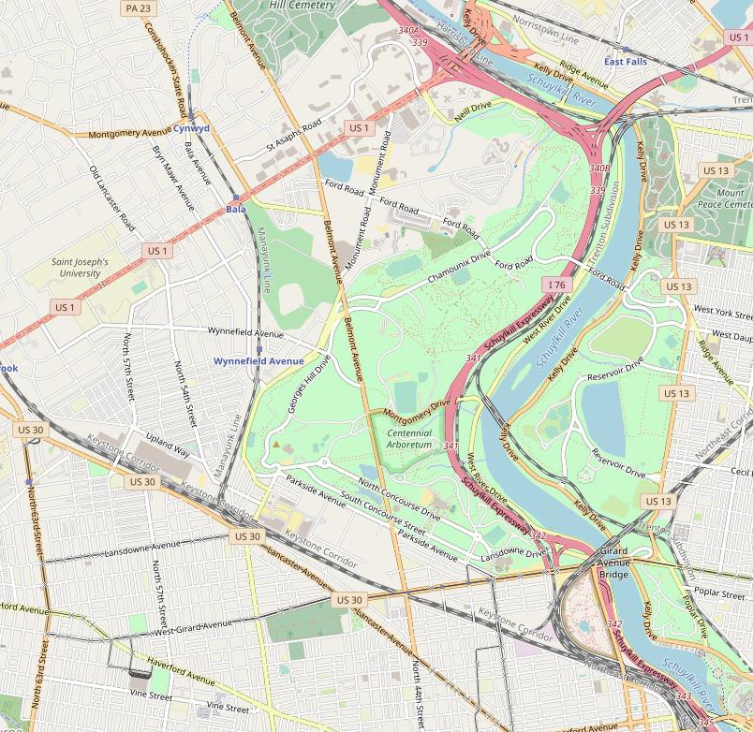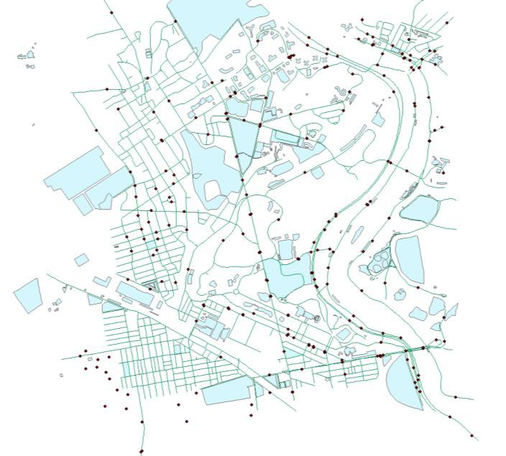

**DVRPC Traffic Data Points**

Roadway parameterization

*Names; lane width, max speed; permissions; etc…*

*Show Dataframe*

O agent HQ locations

Home Intro_N_Background The_Model Virtual_Network Network_Demand Network_Owner_N_Management

Network Demand Virtual Network Agent

**Legend**

**SUMO Drivers**

Type

Characteristics / Rules of behavior

LOS Expectations

Route Choice

Consume/Use

***Level of***

***Satisfaction***

**Infrastructure Asset**

Physical

Attributes

Environmental

Attributes

Deterioration Rate

Condition

Rating

Risk

(Consequence)

Performance

(Actual LOS)

Threshold

(Priority)

modifies

**Infrastructure Owners**

Maintenance

Activity

TAMP Activity

Schedule

Action Trigger

Policy

Objectives

Risk Tolerance

Organizational

Constraints

Budget

Static Parameter

Time Dependent

Parameter

Action & Time

Dependent Parameter

ACTION



Relationship Visualization concept from:

[H. Osman / Automation in Construction 28 (2012) 45-57](https://www.dropbox.com/s/3ztli6rqtvvh98u/Agent-based%20simulation%20of%20urban%20infrastructure%20asset%20management%20activities%20-%202012%20-%20Hesham%20Osman.pdf?dl=0)

Network Demand – Users; Routes; Behavior; Etc…

Description_of_Network_Demand

Driver Behavior

[SUMO-Wiki - Definition_of_Vehicles,_Vehicle_Types,_and_Routes](http://sumo.dlr.de/wiki/Definition_of_Vehicles%2C_Vehicle_Types%2C_and_Routes)

[Car-Following Models - Wiki_Link](http://sumo.dlr.de/wiki/Definition_of_Vehicles%2C_Vehicle_Types%2C_and_Routes#Car-Following_Models)

|  |  |  |  |  |
| --- | --- | --- | --- | --- |
| **Name** Home I lro_N_irYdRtound | | The_Model Virtuai_NeiWork NeiWork_Demand NeiWork_Owner_N _ManagemenI **Description** [Wiki_LINK](http://sumo.dlr.de/wiki/Definition_of_Vehicles%2C_Vehicle_Types%2C_and_Routes) | | |
| begin | (simulation)  seconds | The first time step the values were collected in | | |
| end | (simulation)  seconds | The last time step + DELTA_Tin which the reported values were c ollected | | |
| edge@id | (edge) id | The name of the reported edge | | |
| lane@id | (lane)id | The name ofthe reported lane | | |
| 3ampledSecond3 | s | Number seconds vehicles were measured on the edge/lane (may be subseconds if a vehicle enters/leaves the edge/lane).Please note that this value is the sum of the measure times of all vehic les. | | |
| **traveltime** | s | Time needed to pass the edge/lane, note that this is just an estimation based on the mean speed,not the ex act time the vehicles needed. The value is based on the time needed for the front of the vehicle to pass the edge. | | |
| overlapTraveltime | s | Time needed to pass the edge/lane completely, note that this is just an estimation based on the mean speed, not the exac t time the vehicles needed. The value is based on the time any part of the vehicle was the edge. | | |
| den3ity | #veh/km | Vehicle density on the lane/edge | | |
| occupancy | % | Occupancy of the edge/lane in % | | |
| waitingTime | s | The total number of seconds vehicles were considered stopped | | |
| 3peed | m/s | T | he mean speed on the edge/lane within the reported interval. | |
| I  **Caution:**  This is an average over time, rather than an average over the vehicles. Since slow vehicles spend more time on the edge they will have a proportionally bigger influence on average speed. |  |
| departed | #veh | The number of vehicles that have been emitted onto the edge/lane within the described interval | | |
| arrived | #veh | The number of vehicles that have finished their route on the edge lane | | |
| entered | #veh | The number of vehicles that have entered the edge/lane by moving from upstream | | |
| **le=t** | #veh | The number of vehicles that have left the edge/lane by moving downstream | | |
| laneChangedE'rom | #veh | The number of vehicles that changed away from this lane | | |
| laneChangedTo | #veh | The number of vehicles that c hanged to this lane | | |
| vaporized | #veh | The number of vehicles vaporized on this edge **(only present if #veh > 0)** | | |

Calibrators

Home lntro_N_Background The_Model Virtuai_Network Network_Demand Network_Owner_N_Management

I....

:::::l

0

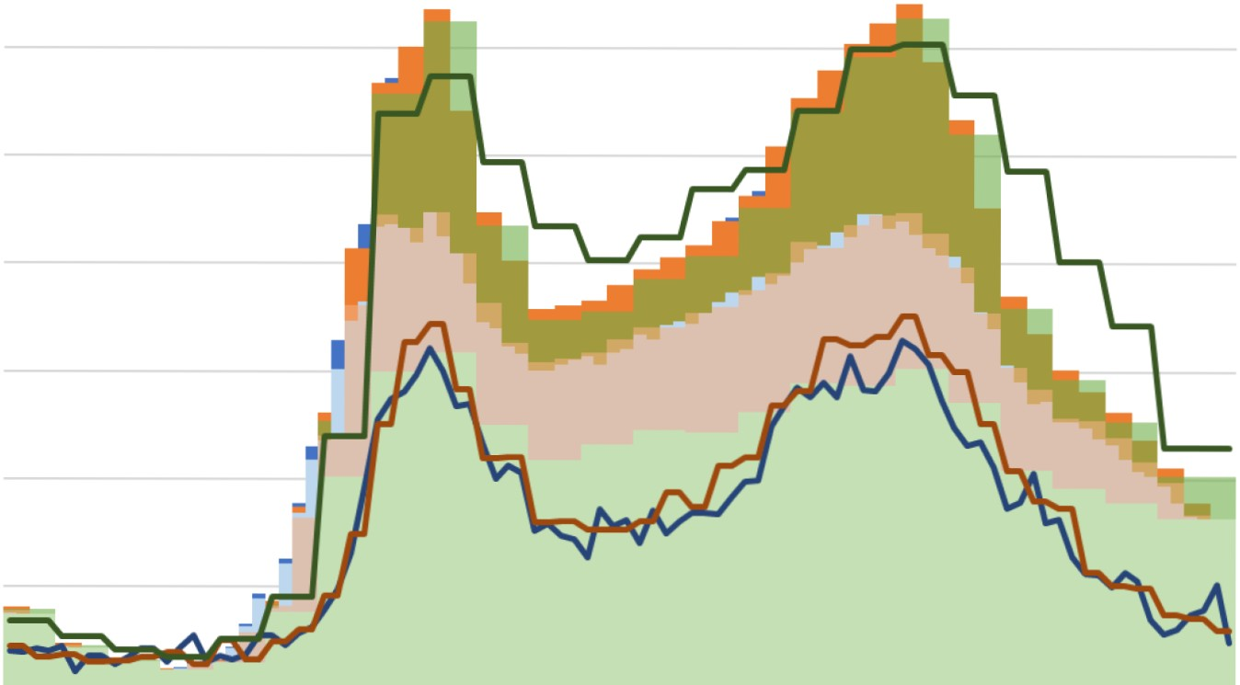

35,000.00

30,000.00

25,000.00

Aspired_Fiows vs Modeled_Fiows

60%

50%

(l)

40% u

c

(l)

I I....

I....

(l)

a.

*V)* (l) u

...c

(l)

20,000.00

15,000.00

£

30% Cl

+c-'

(l)

(l) u I....

>

10,000.00

5,000.00

0.00

0 0 0 0 0 0 0 0 0

0 0 0 0 0 0 0 0 0 0 0 0 0 0 0

20%

10%

0%

(l)

a..

0 0 0 0 0 0 00

en Ll) or-i " M en Ll) or-i

,......

0 00

M en Ll) or-i

,...... ,......

,......

0 0 0 00

M en Ll) or-i

,......

0 0 00

M en Ll) or-i

,......

<:::t 00 or-i Ll) 00 N en

or-i or-i or-i N N N

M 0 <:::t ,...... or-i <:::t 00 N Ll) en N 0 M M M <:::t <:::t <:::t Ll) Ll) Ll) 00 00

Running time (sec)

- 15-min-SUM-aspired

15-min-intervalsSUM-ActuaI

- 30-min-interval-aspiredFiow-SUM 60-min-interval-aspiredFiow-SUM

30-min-interva1-modeledFlow-SUM 60-min-interva1-modeledFlow-SUM



- 15-min-%-Diff - 30-min-%-Diff - 60-min-%-Diff

Calibrators

Calibrators Pulsing running vehicles over time

2000 ------------------------------------

1900 - num 4

1800 - rum s l

- 1700 -

=tt: 1600 -

num_6_Short lntervaIs

R..- --------l

......... 1500 -1----------------------- -- _._...+-+------- -l

lll 1400

*Q)* 1300 -!--------------------- - - - - .,...... ' -- -1

u 1200 r. • 11 I '·

.,C 1100 I n \ "" rti--H----- -t

*Q)* 1000 :, - *('*

::> 900 I '-1- 1 n !-!-

,...,.. 800 .,!u IL

c' *1oo* ULr(h to \

I r ' I L ' II

r· 1 lt \, [1............,1------l

C 6oo l11 - 1 L J.:.r!"" J 1- --..-J

c:: soo

fu [ 11 ,

- -u"

r:--

f-i

::J 4oo :i I l) r·l u • lli -

r )

l..... 3oo --· fJ llf V,

200 11-: Ill I ,'lJH •

*t*

10 11t1ij'"q11J-!Jr,r- ' - - _, JJ"

00:00 04:00 08:00 12:00 16:00 20:00 24:00

time

Home lntro_N_Background The_Model Virtuai_Network Network_Demand Network_Owner_N_Management

2000

1900

- num_4

- num_5

- num_6_5hort_lntervals

Calibrators Pulsing running vehicles over time

.

~~"~~

1800

1700

- num_13-15min_test_cars-Yroutes num_13-30min_test_cars-Yroutes

- num_13-60min_test_cars-Yroutes

-

**Jli l.** -

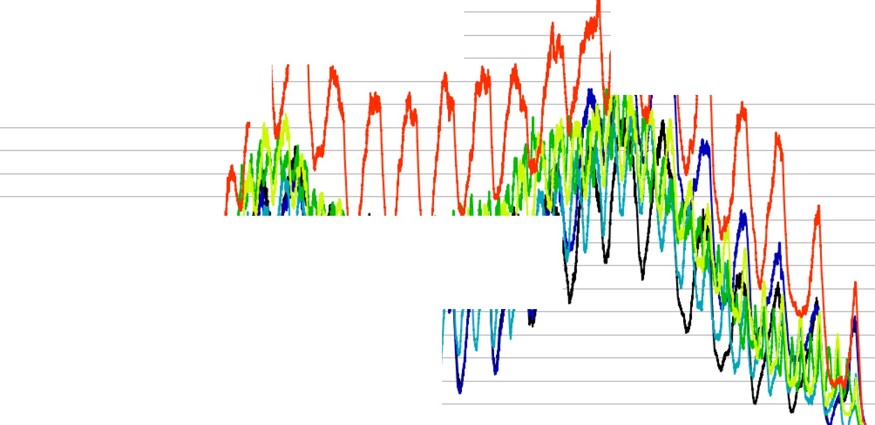

- **,l_r . _ J**

1600 --

'

1500

1400 -

Vl 1300

*Q)*

u 1200

.c. 1100

*Q)*

> 1000

0c'1 900

c 800

§ 700 -

1....

600

500

------------------

400 - **j** r---

|  |  |  |  |
| --- | --- | --- | --- |
| 300 |  |  | 11 ,.., ; |
| 200 | .1. | -.--- | **T** 1r.,_1.fl-f.. _ |

100 J,J_jj - . **fA** "RI

***'fA* I'"J[1l.ili.ll ,**

0 *r* n m. .,*Jn l* Jll *1*

00:00



04:00 08:00 12:00

time

16:00 20:00 24:00

Test Bed for Calibrators

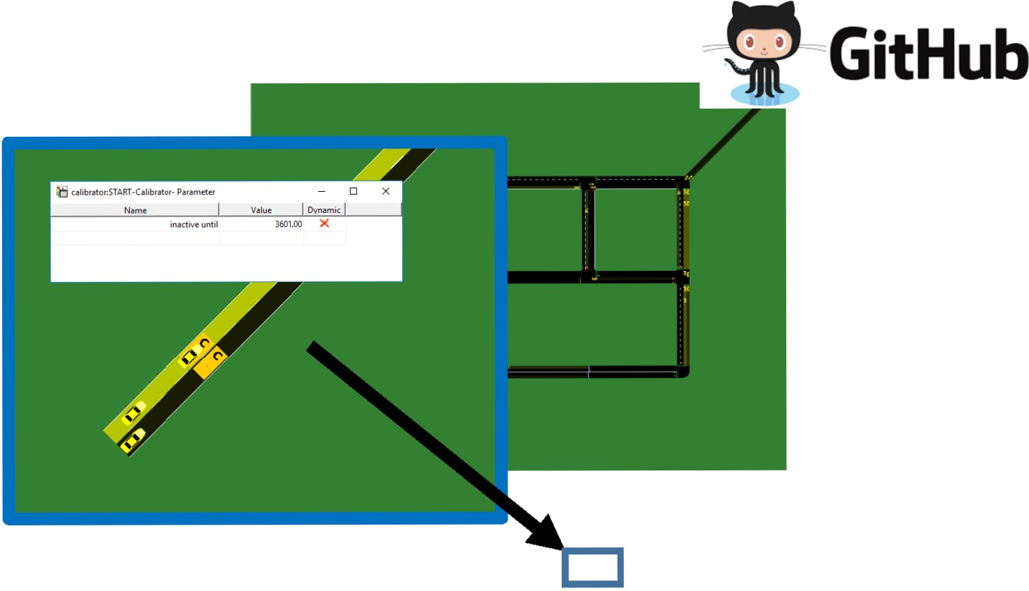

30,000.00

25,000.00

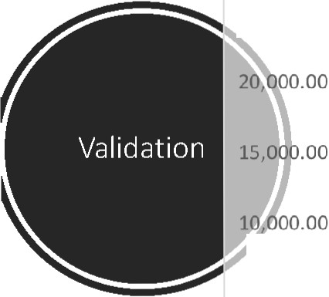

5,000.00

Vehs Runnings per Hour

•Running

•SUMMED VALUES

- From DVRPC

•Trial

0 2 4 6 8 10 12 14 16 18 20 22 24

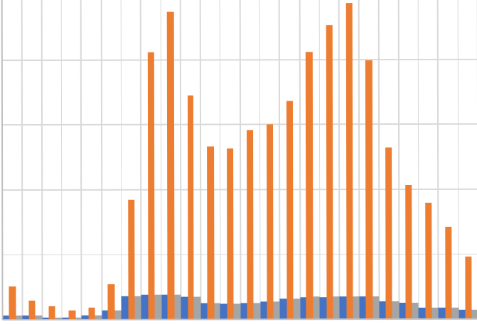

cailTEST-NR-F20-vph-DVRPC-5-Cal Number of Cali brators 5 Freq 20 vph DVRPC Distri bution

I

|  |  |  |  |  |  |  |  |  |  |  |  |  |  |  |  |
| --- | --- | --- | --- | --- | --- | --- | --- | --- | --- | --- | --- | --- | --- | --- | --- |
| interval_id | Average  Percent  Diff | %Diff-  3600 | %Diff-  7200 | %Diff-  10800 | %Diff-  14400 | %Diff-  18000 | %Diff-  21600 | %Diff-  25200 | %Diff-  28800 | %Diff-  32400 | %Diff-  36000 | %Diff-  39600 | %Diff-  43200 | %Diff-  46800 | %Diff-  50400 |
| START-Calibrator | 36% | 19% | 22% | 19% | 15% | 19% | 31% | 35% | 52% | 55% | 48% | 41% | 47% | 46% | 49% |
| 2 1-1 1-Calibrator | 41% | 29% | 29% | 27% | 22% | 19% | 31% | 43% | 58% | 59% | 53% | 46% | 52% | 51% | 56% |
| 1 1-2 1-Calibrator | 47% | 40% | 19% | 34% | 19% | 25% | 41% | 52% | 66% | 68% | 62% | 54% | 58% | 62% | 61% |
| 0 0-0 1-Calibrator | 50% | 34% | 40% | 27% | 24% | 36% | 43% | 52% | 68% | 69% | 66% | 57% | 61% | 64% | 65% |
| 3 1-3 0-Calibrator | 88% | 84% | 74% | 71% | 66% | 81% | 91% | 94% | 98% | 97% | 97% | 95% | 97% | 96% | 97% |
|  | 14% |  | | | | | | | | | | | | | |

caliTEST-NR-F15-vph-DVRPC-5-Cal Number of Cali brators 5 Freq 15 vph DVRPC Distri bution

|  |  |  |  |  |  |  |  |  |  |  |  |  |  |  |  |
| --- | --- | --- | --- | --- | --- | --- | --- | --- | --- | --- | --- | --- | --- | --- | --- |
| interval_id | Average Percent Diff | %Diff-  3600 | %Diff-  7200 | %Diff-  10800 | %Diff-  14400 | %Diff-  18000 | %Diff-  21600 | %Diff-  25200 | %Diff-  28800 | %Diff-  32400 | %Diff-  36000 | %Diff-  39600 | %Diff-  43200 | %Diff-  46800 | %Diff-  50400 |
| START-Calibrator | 28% | 9% | 10% | 17% | 15% | 7% | 14% | 29% | 48% | 51% | 42% | 33% | 37% | 38% | 43% |
| 2 1-1 1-Calibrator | 34% | 20% | 14% | 12% | 15% | 13% | 28% | 36% | 54% | 57% | 49% | 40% | 47% | 45% | 52% |
| 0 0-0_1-Calibrator | 42% | 8% | 26% | 7% | 15% | 6% | 40% | 52% | 68% | 68% | 64% | 56% | 58% | 64% | 61% |
| 1 1-2 1-Calibrator | 44% | 34% | 28% | 12% | 5% | 22% | 43% | 54% | 66% | 66% | 61% | 55% | 58% | 60% | 58% |
| 3 1-3 0-Calibrator | 89% | 83% | 84% | 66% | 76% | 79% | 91% | 94% | 97% | 98% | 97% | 95% | 96% | 96% | 97% |
|  | 17% |  | | | | | | | | | | | | | |

cailTEST-NR-F5-vph-DVRPC-5-Cali Number of Ca li brators 5 Freq 5 vph DVRPC Distri bution

|  |  |  |  |  |  |  |  |  |  |  |  |  |  |  |  |
| --- | --- | --- | --- | --- | --- | --- | --- | --- | --- | --- | --- | --- | --- | --- | --- |
| interval_id | Average  Percent  Diff | %Diff-  3600 | %Diff-  7200 | %Diff-  10800 | %Diff-  14400 | %Diff-  18000 | %Diff-  21600 | %Diff-  25200 | %Diff-  28800 | %Diff-  32400 | %Diff-  36000 | %Diff-  39600 | %Diff-  43200 | %Diff-  46800 | %Diff-  50400 |
| START-Calibrator | 13% | 6% | 3% | 5% | 5% | 4% | 7% | 9% | 29% | 30% | 21% | 11% | 14% | 15% | 22% |
| 2 1-1 1-Calibrator | 16% | 9% | 10% | 12% | 2% | 4% | 9% | 17% | 27% | 34% | 24% | 14% | 20% | 19% | 27% |
| 1 1-2 1-Calibrator | 42% | 35% | 24% | 17% | 5% | 22% | 35% | 50% | 63% | 66% | 57% | 49% | 56% | 57% | 57% |
| 0 0-0 1-Calibrator | 46% | 23% | 0% | 0% | 0% | 6% | 30% | 60% | 79% | 82% | 77% | 69% | 70% | 75% | 76% |
| 3 1-3 0-Calibrator | 89% | 85% | 76% | 73% | 71% | 85% | 93% | 93% | 97% | 98% | 97% | 96% | 96% | 95% | 96% |
|  | 21% |  | | | | | | | | | | | | | |

I

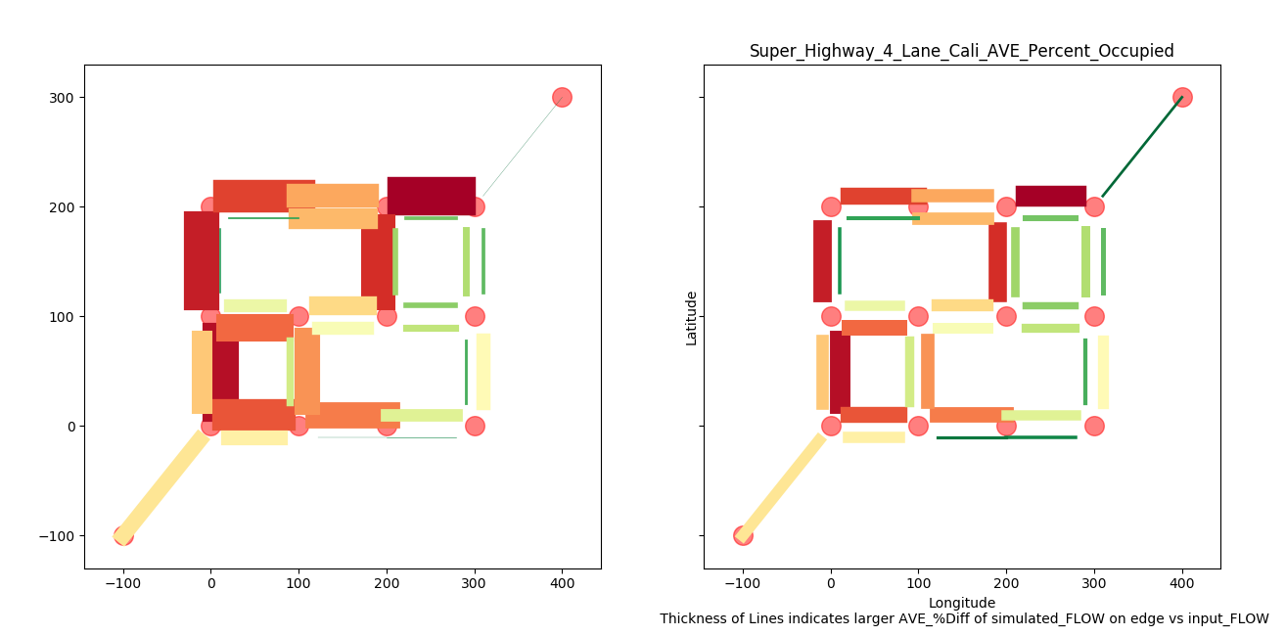

Percent Error – Aspired Flow v Simulated Flow

Data sources

*Specific roadway flow counts*

*Vehicle type distribution*

Home Intro_N_Background The_Model Virtual_Network Network_Demand Network_Owner_N_Management

Network Demand Virtual Network Agent

**Legend**

**SUMO Drivers**

Type

Characteristics / Rules of behavior

LOS Expectations

Route Choice

Consume/Use

***Level of***

***Satisfaction***

**Infrastructure Asset**

Physical

Attributes

Environmental

Attributes

Deterioration Rate

Condition

Rating

Risk

(Consequence)

Performance

(Actual LOS)

Threshold

(Priority)

modifies

**Infrastructure Owners**

Maintenance

Activity

TAMP Activity

Schedule

Action Trigger

Policy

Objectives

Risk Tolerance

Organizational

Constraints

Budget

Static Parameter

Time Dependent

Parameter

Action & Time

Dependent Parameter

ACTION



Relationship Visualization concept from:

[H. Osman / Automation in Construction 28 (2012) 45-57](https://www.dropbox.com/s/3ztli6rqtvvh98u/Agent-based%20simulation%20of%20urban%20infrastructure%20asset%20management%20activities%20-%202012%20-%20Hesham%20Osman.pdf?dl=0)

Routes

Heuristics

*Try without and see if we can go for a longer*

Dynamic User Assignment

Home Intro_N_Background The_Model Virtual_Network Network_Demand Network_Owner_N_Management

Network Demand Virtual Network Agent

**Legend**

**SUMO Drivers**

Type

Characteristics / Rules of behavior

LOS Expectations

Route Choice

Consume/Use

***Level of***

***Satisfaction***

**Infrastructure Asset**

Physical

Attributes

Environmental

Attributes

Deterioration Rate

Condition

Rating

Risk

(Consequence)

Performance

(Actual LOS)

Threshold

(Priority)

modifies

**Infrastructure Owners**

Maintenance

Activity

TAMP Activity

Schedule

Action Trigger

Policy

Objectives

Risk Tolerance

Organizational

Constraints

Budget

Static Parameter

Time Dependent

Parameter

Action & Time

Dependent Parameter

ACTION



Relationship Visualization concept from:

[H. Osman / Automation in Construction 28 (2012) 45-57](https://www.dropbox.com/s/3ztli6rqtvvh98u/Agent-based%20simulation%20of%20urban%20infrastructure%20asset%20management%20activities%20-%202012%20-%20Hesham%20Osman.pdf?dl=0)

Infrastructure Asset Own Agent

Link to Model Components

Home lntro_N_Background The_Model Virtuai_Network Network_Demand Network_Owner_N_Management

$ I **Owner Agent**

IMulti-Objective Creates work plan I Takes Actions during

0pr1m10 zar1on

schedule to meet

.,;.,__ simulation

I predef0ined goals

I

I I I

Sends out limited work Halts scheduled Combined Asset Management (roadway and bridges) force to complete work to react to scheduled work emergency event

I

I I

Network Optimization Single Asset Consideration Service Provided (Human Focused)

*(Holistic care of inventory) ;:*

R Corridor

t ] ( Measures:

I

**_l**

/Actions based on?

I

Measures:

--

lMeasures: J

ep1acemen

[ C02 } Asset Lifecycle Cost J

Emissions

K Lateness]

( Total }

**t** Average Speed ] Ride J

Expenditures Quality

(Cost Min/

( Average } Age Max Average Queue Length] Safety J

**H**

Speed Condition J

f Average Delay t Based Condition Rating ] Number of

**y** Number of

Accidents J

Percent of Network in } Ride QualityJ

Condition Statel..n



Number of Pot Holes J

Emergency Stops

Home Intro_N_Background The_Model Virtual_Network Network_Demand Network_Owner_N_Management

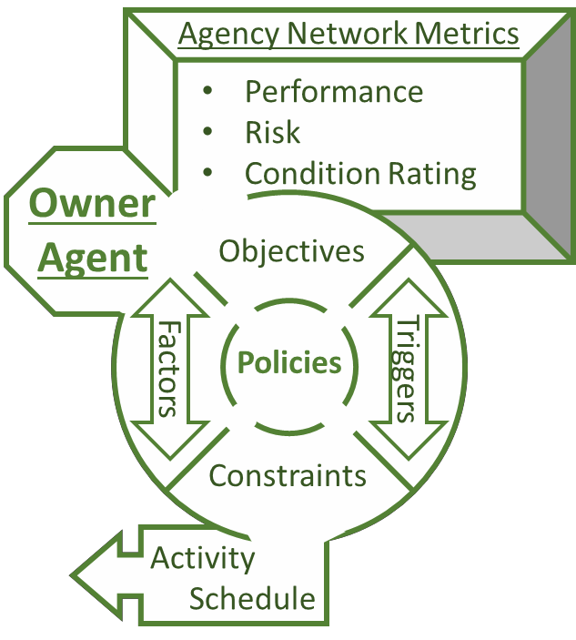

Owner Agent – Tentative

Rules of Behavior – Detailed

**Rules of behavior**

Statistical and Probabilistic, but Simulated

Emergent Behavior is Non-Deterministic

• Non-linear programing – Schedule

Optimizer

•Objective function variation: short term

cost minimization, overall network

performance maximization, LCC

minimization, Holistic Livability

maximization

•Subject to:

• Budget – next year’s budget (Probabilistic) – soft constraint

• Number of overlapping activities – (Deterministic) – hard constraint –

Availability: Labor Force, Equipment, Material In-Stock, Completion time

of activity (Probabilistic)

• Available activities - (Deterministic) – Work force capabilities

• Effectiveness of activity – (Probabilistic) – Variation in condition increase

base on quality control practices

• Cost of project – (Heuristics and Probabilistic) - variations in material cost

based on seasonal adjustments and market fluctuation

• Scope of activities – (Deterministic) – soft constraint – Policy driven –

example: PWD can not contribute funds to any project that’s scope is

outside of their jurisdiction, due to their bonding arrangement.

• Condition data:

• Probabilistic – Data collection practices → probability inspection data is

reported correctly

• Deterministic – Data collection practices → condition data update rate

• Indirect Deterioration costs – Statistical and Non-Deterministic:

• Importance factor: i.e. - Change in vehicle flow rate per year given no

maintenance activities and default flow rates.

• User experience - Statistical and Non-Deterministic:

• Simulated vehicle interactions create differences between the routes expected

travel-time and the actual travel time, experience is quantified as the piece-

wise integral of the negative intensity over the time period above the

threshold.

Description of Owner Agent Purpose Capabilities

Operation Research Scheduling Decision Module

lntro_N_Background The_Model Virtuai_Network Network_Demand

Network_Owner_N_Management

• Juncllon.J and KIJthf..o)f' dtflnltlons

• A·,allablt Outputs

rdtt!au1nffis: "tfllaH-blHt•wkOt"mllt<'f mn um UC!U!'sd \ mhp• "'r!'•m:tct.:c-na.,....,utd lf1•...-lr. JH'rr.,......lt<'f mni•r"r..t•cll•\mltn• ''•"dud

fdgtfanr t•' 'm" :ret ·\8kular po11w..1 rlllkiiM

:tdcti\aM--tNI.wd 'thk•luHlw tml.nkMI: lN.M'd

on lbrmoMiw

Operator Allribute



oawu un 1n10rmauon

uhed bilrHII.SHU

9.1Wtt.!!!.R!!!:laaf'-baH'd C"alc•la!loonflf !ht' Kl•aleallbark I•

rro r.r• jnnlon

Simulation based ESAL

• Road¥<aPtrttiU Coadlll..Ralln(PCR).t:dgt

Qututl nc.D«bJon Optloas and tCKU

R uin of BC"hnior

• \tlntml/e-C c

• \blncaln all antiJ at a minimum PCR

\ltmot')

• Puc tdgtla nt tnffit palltras. prir«

thickness of

Pavement Condition Rating (PCR) as a function of Material,Thickness,and ESAL

-... ..-.....

..,.._..

Roadway

._ .-..."..'....

ttp.lk..t..fM,f'lt ""'' ·---

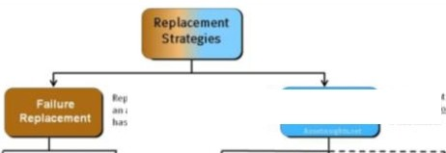

•Runto F tt!M• UnlntendH

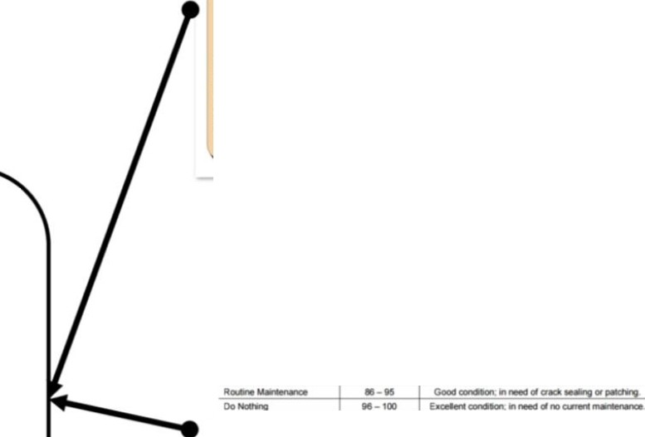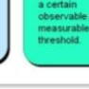

_u n, ,..u,

•··- CondiiiO•ft·

Selected Roadways to Improve. PCR is uBased on

·-K-..-...,-- -

R•plac..,..m

..

---·

---·.

-._....-......

-

......

............,

- -

-llt.p.-c.·...

.....

.._..

f

..

..... -

,..."

"....,......

..... ..,.

--

Repair Option's Ability to Restore

, _,... ..

..............

.,.........

·--

...

*Min Lb Lr Repair _edgeN* (i) *@yearr* • *Repair _Cost@yearr*

.....

. ... -·P -....,_.,.....

--

....

-

*Objective Function :*

...........,.,....,.,_...,.......,.o c.....,.._...,..........,...............

Where the repair_edge variable is binomial.

*Subject to:*

...-on.-....:. - ...,..,.......,. ............,onfKIICal

T

0-80

..,..

Time since last repair less than or equal to 15 years

(TSLR) :S 15 yrs

PCR(TSLR) 2: 50

TotalCosts cannot exceed budget

*LRepair_edgeN* G)

*N*

.._.............,. 10-n ,., .,..,..•:=--..,.,_.•.....,.

............. *n-•* ,....,.......................,

. . Oft ..................,.. . klllllwfo4l ..-----w.-

... -,_._-............. AYER .......

T... JP8WifMfll _,..,OpticNia & UNl CoMa

oa I

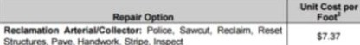

*@yearr* • *Repair cost@yearr* S *Budget*

,..,._.......c. .e.,:..:.."*- ,..,... .....

....

0-10

0-10

The issue that I am having is that once the repair is chosen the TSLR has to be

.=.!"..0,0...-.,L-oc_E....T._

-0.., --RO: O:- ·--+- -- -i i' •- =- - n,.-=-

I -

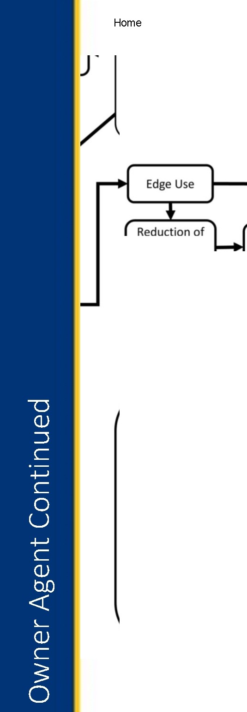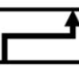

reset. Such that TSLR[i]= (TSLR[i-1]*(Repair_edgerl+1

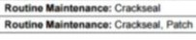

...,_.., P*l8 ....._ ..T.a.Pwe. ua eo-n

r-:

1001 .,_•

.'..----1.-·=·"

Home Intro_N_Background The_Model Virtual_Network Network_Demand Network_Owner_N_Management

Linear Programing Example

Non-Linear Integer Programing for Planning Street Maintenance.

Objective Function:

𝑇 𝑁 0

𝑀𝑖� σ0 σ1

1

𝑅��𝑎���__ �����𝑁

@𝑦����𝑇 ∗ 𝑅��𝑎��� ����@������𝑇

Where the repair_edge variable is binomial.

Subject to:

1. Time since last repair less than or equal to 15 years a.(TSLR) ≤ 15 yrs

2. The percent condition rating as a function of TSLR must be greater or equal to 50

a. PCR(TSLR) ≥ 50

3. Total Costs cannot exceed budget

a. σ𝑁

1

𝑅��𝑎��� �����𝑁

0 @������ ∗ 𝑅��𝑎��� ����@������ ≤ �������

1 𝑇 − 𝑇



The issue that I am having is that once the repair is chosen the TSLR has

to be reset. Such that TSLR[i]= (TSLR[i-1]*Repair_edgeT) +1

Once I can solve this problem the Repair_Edge variable will be a vector related to different types of repair options. I will construct the constraints to be based on the PCR only certain repair options will be available. Below is an example of different repair options, their costs, and ranges for what options should be applied. In the example they use PCI as their condition variable, but it is just a pavement index. I chose the PCR because it takes into account the effects from traffic.

Owner Agent Continued

thickness of

Roadway

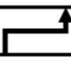

Pavement Condition Rating (PCR} as a function of Material,Thickness,and ESAL

Selected Roadways to Improve. PCR is uBased on

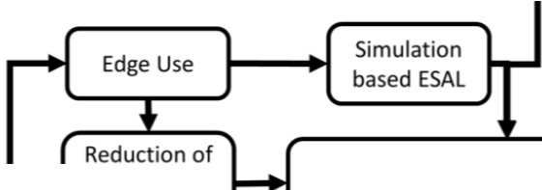

Repair Option's Ability to Restore

Replacement Optimizati on Algorithm:1 st Attempt



*Objective Function :*

*Min "L"L Repair_ed9eN* (i) *@yearr * Repair _Cost@yearr*

Where the repair_edge variable is binomial.

*Subject to:*

Time sni ce last repair less than or equal to 15 years

(TSLR) s 15 yrs

The percent condition rating as a function of TSLR must be greater or equal to 50

PCR(TSLR) 2: 50

TotalCosts cannot exceed budget

*LRepair_edgeN* (¥)*@yearr* • *Repair cost@yearr* :S *Budget*

*N*

I -

The issue that Iam having is that once the repair is chosen the T5LR has to be reset.Such that TSLR[i]= (T5LR[i-1]*(Repair_edgerl+1

**Provincetown Pavement Treatment Categories**

In oroer to provide the Tov.n with area-specific pavement treatment and repair alternatives the pavement conditionindex (PCI) was broken down into the following distribution based on typical maintenance strategies:

Table 2 Provincetown Maintenance & Repair Strategies

|  |  |  |
| --- | --- | --- |
| -n-ee & Repa r  C8111gory_ | PCI | Condition |
| Base Rehabilitation | 0-59 | Failed CondHion;in need of f\AI reconstruction including base layer |
| StructuralImprovement | 60 -72 | Poor condition;inneed of additional thickness to suppo<t  traffic. |
| Preventative Maintenance | 73-85 | Fair condition;in need of surface sealing or thin oveay. |
| Routine Maintenance | 86-95 | Good condition; in need of crack sealing or patching. |
| Do Nolhing | 96-100 | Excelent condition;inneed of no current maintenance. |

Based on the above maintenance and repair strategies the following pavement repair options and unit costs were created for Provincetov.n and incorporated into the MicroPAVER software:



Table 3 Provincetown Pavement Repair Options & Unit Costs

|  |  |  |
| --- | --- | --- |
| Repair Option | Unit Cost per  Foof | PCI I |
| Reclamation ArteriaUCollec1or: Pollee. Sawcut. Redaim. Reset  Structures.Pave.Handwork. Stripe.Inspect | $7.37 | 0-59 |
| Reclamation Local Pollee. Sawcut. Redaim. Reset Structures. Pave.Handwork.Inspect | $5.<41 | 0-59 |
| MIIVOvertay Arterial/Collector: Police, Sawcut. Mil, Tack,Pave. Stripe | $2.82 | 60-72 |
| MIIVOverlay Local Pollee,Sawcut, Mill,Tack, Pave | $2.00 | 60-72 |
| Thin Overlay:Pollee,CrackseaVpatch.Tack. ay | $1.45 | 73-85 |
| Chfpseaf:Crackseai/Patch.Chipseaf | $0.63 | 73-85 |
| Routine Maintenance:Crackseal | SO.ot | 92-95 |
| Routine Maintenance:Crackseal,Patch | $0.07 | 86 - 91 |

Home lntro_N_Background The_Model Virtuai_Network Network_Demand Network_Owner_N_Management

Replacement

Strategies

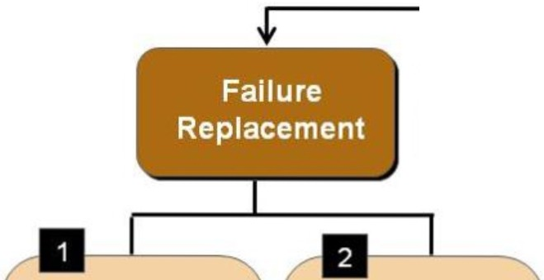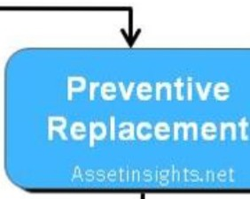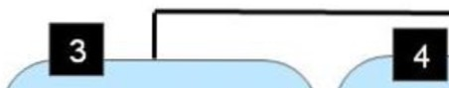

Replacement of an asset a fter it has failed.

Replacement of an asset before it has failed.



Run to Failure Unintended Time-Based Age-Based Condition-

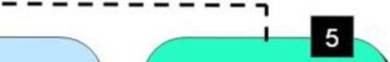

(RTF) Failure Replacement Replacement Based

Replacement (TJ?R) (AbR) Replacement

(UFR) (CbR)

A conscious The owner Replace the Replace the Replace the decisionis made makes no plans asset on a fixed asset when it asset when its to neglect the and simply interval, such reached age "x" performance asset until it fails. reacts once as ·'x" number or failure, deteriorates The owner failure has of years or "x" whichever below understands the occurred. Failure number of run comes first.Age a certain consequences of was not intended hours. is defined as observable *I* failure nor anticipated. "chronological" measurable

age or threshold.

"effective" age.

Spy Pond's Recommendations

[DroboxUNK](https://www.dropbox.com/s/eawiyk3gfrj99qy/Philadelphia%20Department%20of%20Streets%20Asset%20Management%20Implementation%20-%20Spy%20Pond%202012.pdf?dl=0)

Table 1. ReoonmiJI.ended Rel.isions to PRISi Treatments

|  |  |  |  |  |
| --- | --- | --- | --- | --- |
| Tre.abnent | Treatment Cost ($/sq.yd.J | | | Notes |
| Previous | Revised | Revised  w/ADA |
| Oracle Sealing | *054* | 0.72 | *o_n* | used sameirncrease as slurrv seal |
| S!lurrv Seal | 1_5() | .2Jl0 | 2_00 |  |
| Microsurfacing | 3_65 | 4Jl0 | 4_00 | change effect from r etting lfie to irnareasirnglife by 7 years |
| Hot- n-Place Recyding | 4_70 | 9_40 | 37_40 | used sameirncrease as t:hjn miII |
| Nova-Chip with  Heater Scarification | 5_00 | N/A | N/A. | eliminate t:reatmernt |
| Tnin Mjlland Inl ay | 7_00 | 14Jl0 | 42JXl |  |
| Col d-inrP ace  Recycling | 3_00 | 8750 | 115_50 |  |
| Compete  Re.constlruction | 65.00 | 130_00 | 158JXl |  |

Home Intro_N_Background The_Model Virtual_Network Network_Demand Network_Owner_N_Management



Next Steps

**SUMO (90% complete)**

• Finalize Traffic [flow calibrators](http://sumo.dlr.de/wiki/Simulation/Calibrator) for the AOI network (95%)

[• Link to DVRPC Traffic Count Excel Data](https://www.dropbox.com/s/h7y28db3f12calv/DVRPC%20Traffic%20Counts%20For%20Net%20OSM%202%20-%20V-3%209.1.xlsb.xlsx?dl=0) Extracted from [DVRPC Web App](http://www.dvrpc.org/webmaps/TrafficCounts/)

• Incorporated the pavement deterioration function into the SUMO model and have the current condition affect the max speed over the pavement segment. (95%)

• Incorporate a user ELOS function based on user travel time, pavement condition, and accident rate to keep track of user experience (85%)

• Develop Initial or Changes to Existing Conditions for Scenarios and Assess Changes

Owner Agent – Next Page

Home Intro_N_Background The_Model Virtual_Network Network_Demand Network_Owner_N_Management



Next Steps

**Owner Agent (70%) –** [**link to PowerPoint with TAMP framework components – 70%**](https://www.dropbox.com/s/ozdpx0tgm08aety/PhD%20TAMP%20Framework%201.30.18.pptx?dl=0)

• Translate [FHWA’s TAM Framework](https://www.fhwa.dot.gov/asset/plans.cfm) into the Owner Agent’s operational

parameters and functionality

• Define and translate the different management principles into a standard linear or non-linear programing format.

• Multi-objective constrained optimization: Short-term operations scheduling and Long-term planning

• Create a transportation asset management framework and code to interface with the SUMO simulation for managing the transportation assets.

• Identify the critical elements from FHWA’s Best Practices and PennDOT’s current TAMP

• Conduct interviews with City Streets Department to further map their pavement management process, their constraints, and objectives

• Develop decision and finance routines to simulate owner/operator’s behavior.

• Incorporate aggregate user experiences to increase political pressure (artificially rising priority) on owner agents to fix bad roads that effect the general public.

Description of how the schedule will be made inputs outputs

*Scenarios to run*

Objective Function

Constraints

metrics

Home Intro_N_Background The_Model Virtual_Network Network_Demand Network_Owner_N_Management

Network Demand Virtual Network Agent

**Legend**

**SUMO Drivers**

Type

Characteristics / Rules of behavior

LOS Expectations

Route Choice

Consume/Use

***Level of***

***Satisfaction***

**Infrastructure Asset**

Physical

Attributes

Environmental

Attributes

Deterioration Rate

Condition

Rating

Risk

(Consequence)

Performance

(Actual LOS)

Threshold

(Priority)

modifies

**Infrastructure Owners**

Maintenance

Activity

TAMP Activity

Schedule

Action Trigger

Policy

Objectives

Risk Tolerance

Organizational

Constraints

Budget

Static Parameter

Time Dependent

Parameter

Action & Time

Dependent Parameter

ACTION



Relationship Visualization concept from:

[H. Osman / Automation in Construction 28 (2012) 45-57](https://www.dropbox.com/s/3ztli6rqtvvh98u/Agent-based%20simulation%20of%20urban%20infrastructure%20asset%20management%20activities%20-%202012%20-%20Hesham%20Osman.pdf?dl=0)

Virtual Network Modification Module Python Code

Description of how O agent interacts with V network

True to constraints of OR Schedule

*Physical Representation of workforce enforces logic controls*

Work crews like buses with special stops

*TRAci Python SUMO Interface*

Link back to net work parameters

O agent collects simulation network run data for OR module

*Frequency and Accuracy of update based on agent characteristics*

Home Intro_N_Background The_Model Virtual_Network Network_Demand Network_Owner_N_Management

Network Demand Virtual Network Agent

**Legend**

**SUMO Drivers**

Type

Characteristics / Rules of behavior

LOS Expectations

Route Choice

Consume/Use

***Level of***

***Satisfaction***

**Infrastructure Asset**

Physical

Attributes

Environmental

Attributes

Deterioration Rate

Condition

Rating

Risk

(Consequence)

Performance

(Actual LOS)

Threshold

(Priority)

modifies

**Infrastructure Owners**

Maintenance

Activity

TAMP Activity

Schedule

Action Trigger

Policy

Objectives

Risk Tolerance

Organizational

Constraints

Budget

Static Parameter

Time Dependent

Parameter

Action & Time

Dependent Parameter

ACTION



Relationship Visualization concept from:

[H. Osman / Automation in Construction 28 (2012) 45-57](https://www.dropbox.com/s/3ztli6rqtvvh98u/Agent-based%20simulation%20of%20urban%20infrastructure%20asset%20management%20activities%20-%202012%20-%20Hesham%20Osman.pdf?dl=0)

**TAMP SUB TREE**

**The goal of AM is to maximize the utility of an asset:**

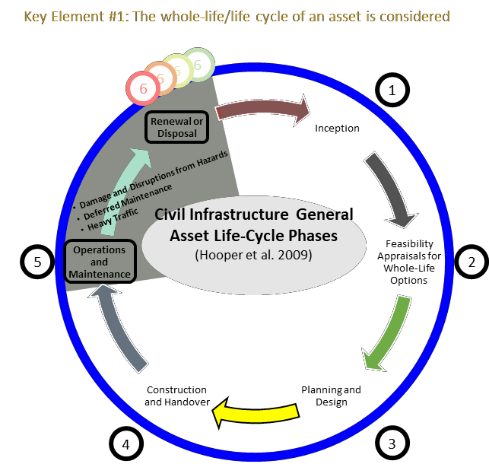

Home Intro_N_Background The_Model Virtual_Network Network_Demand Network_Owner_N_Management

Life-Cycle Phases

• Requires longer initial phases to ensure that the foreseeable future needs asset are not negatively impacted by an initial short term cost minimization approach

• This can result in a significant increase in the length of the operations and maintenance phase

***Ad-hoc planning and maintenance***

• leaves owners without a clear understanding of the future resources that each asset might require

• Under this management style:

• Proper funds can not be allocated beforehand, because the owner is not aware of the asset’s potential needs

• Assets deteriorate at a higher rate, because funds are typically not available or willing to be spent of *preventative maintenance* activities, which can elongate an asset’s life-span and save on costly large repairs and renewal activities.

Proper life-cycle planning can help **control** the length of each phase.

National Debt

.. $$

**National**

**Highway**

**Trust**

**Block Grants to States**



**StateT:u:es**

·

*IS*

**,61**

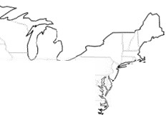

:

$$

l ahJ::::.

**Fu r1**

*"\)*

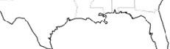

***f?*** State Department of

Transportation

***$t* Jlfllllt**

Gas *,.-,*

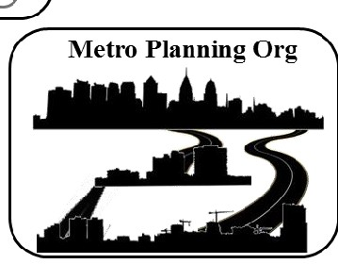

**•t**

I.JJrax

**l!t**

Trans1**•t** Projects

..

$

0

$

$ I$

'

International Infrastructure Management Manual

System Layout; Condition

Data Hierarchy; Assess Protocol,

Data Standards; Rating Expected Life Valuation; Demand Analysis; Data Inventory Methodologies Tables: Balanced Scorecard;

u I Life Cycle Costing

Performance Metrics



_I

r Inventory

Assess Determine Determine

H

Condition, Residual _ Life Cycle Costs Set Target

I Assets

I

I I I I

-.

Failure Modes

Life & Replacement $

LOS

I Assign Determine Determine

I BRE Rating _,. Appropriate r--+ Appropriate *r--+* Fund r-+ Build the AMP (Criticality) Maintenance CIP Your Strategy

·-

FMECA; Business RisK Exp: Delphi Technique



Root Cause; RCM; PdM: ORDM



Confidence Level



Rating:

trategic Validation:

ORDM

Renewal Annuity

Asset Mgt Plan, Polices & Strategy, Annual Budget

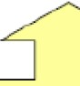

[ASSET MANAGEMENT PLAN CONTEXT](https://www.youtube.com/watch?v=cUXh-hYN6oM&amp;index=1&amp;list=PLhCPG3V68yV6-1gPGXmScnJl30gcxF96U&amp;t=777s)

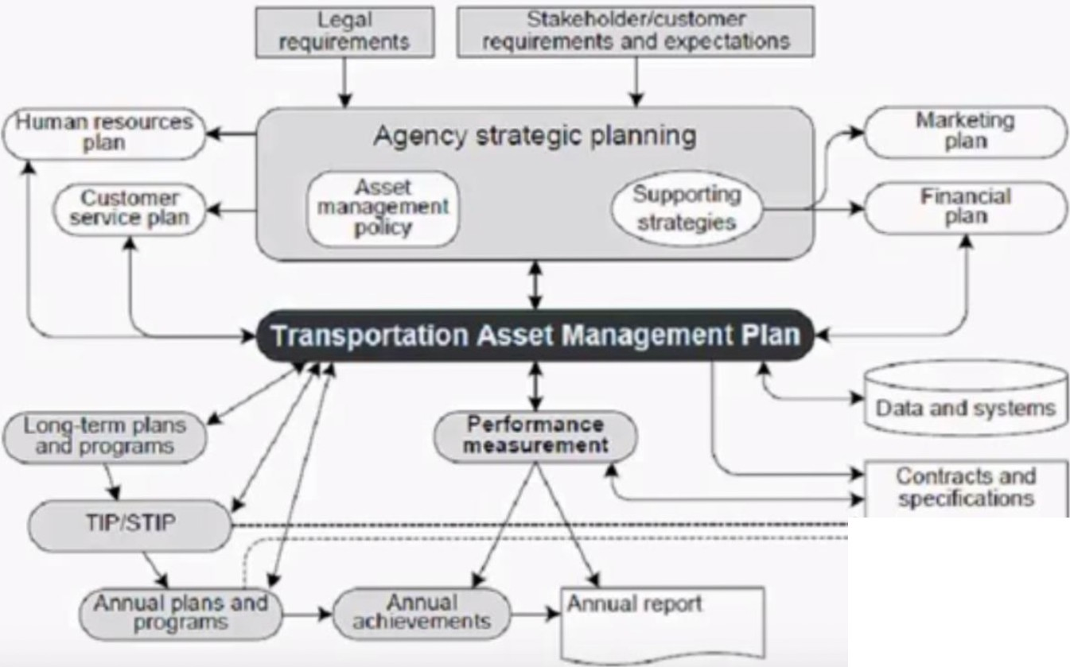

·----::...



Home Intro_N_Background The_Model Virtual_Network Network_Demand Network_Owner_N_Management

Key Elements of Infrastructure Asset Management

1. Taking a life-cycle approach

• The whole-life/life cycle of an asset is considered

2. Developing cost-effective management strategies for the long-term

• Optimization - maximizing benefits by balancing competing demands

• resource allocation - allocation of resources based on asset needs

3. Providing a defined level of service and monitoring performance

• Customer Focus - explicit consideration of customer expectations

4. Understanding and meeting the impact of growth through demand management and

infrastructure investment

5. Managing risks associated with asset failures

6. Sustainable use of physical resources

7. Continuous improvement in asset management practices

Home Intro_N_Background The_Model Virtual_Network Network_Demand Network_Owner_N_Management



SUMO Road Network Levels of Service

• Average Travel Speed - hourly

• Asset & Network – Table B-4

• Signalized Intersections – Table B-6

• ADA Compliant – binary

• State of Repair

• Average for network

• Current after period_i and rate of change from period_i -1 and period_i

Home Intro_N_Background The_Model Virtual_Network Network_Demand Network_Owner_N_Management



SUMO Road Network Performance Measures

• 3.7 Use of Performance Measures

• Providing Feedback for Use in Resource Allocation

• Structured Feedback Process

• Quarterly Management Reviews

• Public Feedback

• Activity Adjustments Based on an Analysis of Trends

• Tradeoff Analysis

3.8 Setting Performance Targets

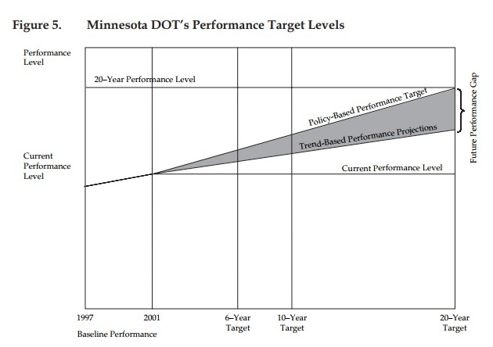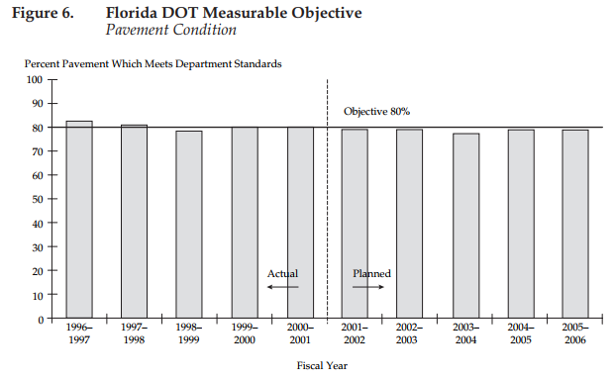

• Anticipated funding level through the forecast horizon (Idaho, Michigan, Minnesota, Montana, Ohio, New York, and Washington);

• Public involvement (Michigan and Montana) and customer-based market research (Minnesota);

• Existing condition (Montana), historical performance trend (Minnesota), limited information on performance compared with other states

(Minnesota), and the implications of different proposed condition levels (Idaho);

• Input from the DOT director, the transportation commission or board, governor’s office, or state legislature (Michigan with Ohio);

• Policy goals/guidance and statewide priorities such as “preservation first” (Florida, New York, and Iowa);

• Discussion with the construction industry (Michigan);

• Life-cycle costs (if a model is available), marginal value of additional investment (100-percent targets are not always advisable) and tradeoff considerations (Minnesota); and

• Priorities by route classification (Iowa)



|  |  |
| --- | --- |
| **TAMP Section** | **Development Topics** |
| 3. Performance Gap  Identifications | If performance targets do not exist, what approach should we use to Identification develop them? |
|  | How will we incorporate expected revenues into the target setting process? |
|  | What information would we like to provide decision makers? |
|  | Who should be involved in the target setting process? |
|  | Are we confident in the future traffic projections needed to model future asset conditions? If not, how can we improve them in the short and/or long term? |
|  | Are we going to separate the analysis by functional class? For example are we going to develop separate targets for the Interstate system, and the rest of the NHS? |
|  | How will we address the relationship between routine maintenance and capital activities/funding? |
|  | How will address the relationship between asset management activities and system expansion activities/funding? |



|  |  |
| --- | --- |
| **TAMP Section** | **Development Topics** |
| 4. Lifecycle Cost | How will we incorporate lifecycle costs into the TAMP? Considerations |
|  | Are they reflected in the management systems that we will use for the analysis? |
|  | How do we manage our assets from inception to disposal, including construction, maintenance, preservation, rehabilitation, improvement, reconstruction, etc.? |



|  |  |
| --- | --- |
| **TAMP Section** | **Development Topics** |
| 5. Risk Management Analysis | What types of programmatic risks will be addressed in the TAMP? |
|  | What is the best way to determine their likelihood and consequences and to identify risk mitigation strategies? (For example, by convening a risk assessment workshop with representatives from throughout the agency.) |
|  | What types of system risks should be considered? (For example, performance failure, weather events, etc.) |
|  | How should we assess system risks? How should the results be presented? (For example, in a statewide map identifying high/med/low risk corridors.) |
|  | How will we incorporate the results of the system risk assessment into the TAMP? (For example, will our investment strategies vary depending on the level of risk? Will the risk mitigation strategies be combined with or compete against our other asset management strategies? |



|  |  |
| --- | --- |
| **TAMP Section** | **Development Topics** |
| 6. Financial Plan | Which portions of the transportation budget will be included in the financial plan? |
|  | How will the anticipated level of these funds be determined? |
|  | Will we allocate funds between asset management and other goal areas such as expansion, or will we focus solely on the allocation of asset management funds between assets? |
|  | What is the value of our assets today? How does it depreciate through the years included in the TAMP. |
|  | Should we consider potential new sources of revenue in the TAMP? If so, which ones? |



|  |  |
| --- | --- |
| **TAMP Section** | **Development Topics** |
| 7. Investment Strategies | Will the TAMP include a list of specific projects? If so, which ones? |
|  | Other than specific projects, what types of investment strategy information will we provide? (Examples include: a description of key strategies, average unit costs, typical timing for when each strategy should be considered; and/or a description of how asset management projects are prioritized and programmed.) |
|  | Which of these items already exist? How should we develop the ones that  don’t? |
|  | How will we will incorporate the results of the risk assessment into our strategies? |
|  | How will we incorporate life cycle cost considerations into our strategies? |



|  |  |
| --- | --- |
| **TAMP Section** | **Development Topics** |
| 8. Asset Management Process  Enhancements | Will we be conducting the Asset Management self assessment survey as part of the TAMP development process? |
|  | If so, who needs to take the survey? How will we facilitate the survey process? |
|  | If not, how will we identify our asset management improvement priorities? |
|  | What information will be provided in the TAMP? (Examples include a summary of the entire survey, a list of the survey items showing the biggest gaps, a list of priority actions categorized as short term and long term, a list of high priority assets to add to the TAMP, etc.) |

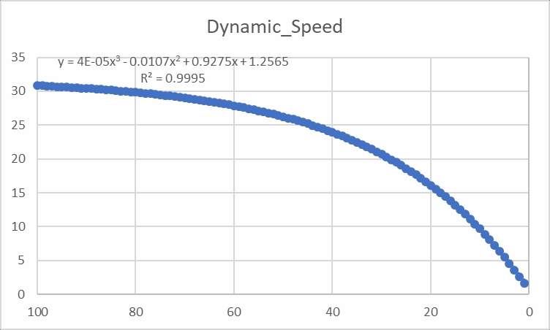

How Condition related to Simulated Speed Limits

SIMULATION’S Max_Speed(PCR)

PCR(t,ESAL,local_conditions)

[Each roadway calculates and updates its “Posted Speed Limt” via SUMO ’s Traci Python Interface. Due to the difference in driving behavior, some vehicles may](http://sumo.dlr.de/wiki/TraCI) still drive a defined percentage above the limit [[speedFactor]](http://sumo.dlr.de/wiki/Definition_of_Vehicles%2C_Vehicle_Types%2C_and_Routes#Speed_Distributions). [Link to Vehicle Parameters]

Link to traci_Python Git_Hub Repository

Home Intro_N_Background The_Model Virtual_Network Network_Demand Network_Owner_N_Management

Using TraCI

• **Protocol specification**

<http://sumo.dlr.de/wiki/TraCI>

• Please see the [TraCI Protocol Specification](http://sumo.dlr.de/wiki/TraCI/Protocol) (including [Basic Flow](http://sumo.dlr.de/wiki/TraCI/Protocol#Basic_Flow), [Messages](http://sumo.dlr.de/wiki/TraCI/Protocol#Messages), [Data Types](http://sumo.dlr.de/wiki/TraCI/Protocol#Data_types)).



• **TraCI Commands**

[• Control-related commands](http://sumo.dlr.de/wiki/TraCI/Control-related_commands): perform a simulation step, close the connection, reload the simulation.

• For the following APIs, the ID is equal to the ID defined in [SUMO](http://sumo.dlr.de/wiki/SUMO)'s input files. Here, you find their [general structure](http://sumo.dlr.de/wiki/TraCI/SUMO_ID_Commands_Structure).

• Value Retrieval

[• Induction Loop Value Retrieval](http://sumo.dlr.de/wiki/TraCI/Induction_Loop_Value_Retrieval) retrieve information about induction loops

[• Lane Area Detector Value Retrieval](http://sumo.dlr.de/wiki/TraCI/Lane_Area_Detector_Value_Retrieval) retrieve information about lane area detectors

[• Multi-Entry-Exit Detectors Value Retrieval](http://sumo.dlr.de/wiki/TraCI/Multi-Entry-Exit_Detectors_Value_Retrieval) retrieve information about multi-entry/multi-exit detectors

[• Traffic Lights Value Retrieval](http://sumo.dlr.de/wiki/TraCI/Traffic_Lights_Value_Retrieval) retrieve information about traffic lights

[• Lane Value Retrieval](http://sumo.dlr.de/wiki/TraCI/Lane_Value_Retrieval) retrieve information about lanes

[• Vehicle Value Retrieval](http://sumo.dlr.de/wiki/TraCI/Vehicle_Value_Retrieval) retrieve information about vehicles

[• Person Value Retrieval](http://sumo.dlr.de/wiki/TraCI/Person_Value_Retrieval) retrieve information about persons

[• Vehicle Type Value Retrieval](http://sumo.dlr.de/wiki/TraCI/VehicleType_Value_Retrieval) retrieve information about vehicle types

[• Route Value Retrieval](http://sumo.dlr.de/wiki/TraCI/Route_Value_Retrieval) retrieve information about routes

[• PoI Value Retrieval](http://sumo.dlr.de/wiki/TraCI/POI_Value_Retrieval) retrieve information about points-of-interest

[• Polygon Value Retrieval](http://sumo.dlr.de/wiki/TraCI/Polygon_Value_Retrieval) retrieve information about polygons

[• Junction Value Retrieval](http://sumo.dlr.de/wiki/TraCI/Junction_Value_Retrieval) retrieve information about junctions

[• Edge Value Retrieval](http://sumo.dlr.de/wiki/TraCI/Edge_Value_Retrieval) retrieve information about edges

[• Simulation Value Retrieval](http://sumo.dlr.de/wiki/TraCI/Simulation_Value_Retrieval) retrieve information about the simulation

[• GUI Value Retrieval](http://sumo.dlr.de/wiki/TraCI/GUI_Value_Retrieval) retrieve information about the simulation visualization

• State Changing

[• Change Lane State](http://sumo.dlr.de/wiki/TraCI/Change_Lane_State) change a lane's state

[• Change Traffic Lights State](http://sumo.dlr.de/wiki/TraCI/Change_Traffic_Lights_State) change a traffic lights' state

[• Change Vehicle State](http://sumo.dlr.de/wiki/TraCI/Change_Vehicle_State) change a vehicle's state

[• Change Person State](http://sumo.dlr.de/wiki/TraCI/Change_Person_State) change a persons's state

[• Change Vehicle Type State](http://sumo.dlr.de/wiki/TraCI/Change_VehicleType_State) change a vehicle type's state

[• Change Route State](http://sumo.dlr.de/wiki/TraCI/Change_Route_State) change a route's state

[• Change PoI State](http://sumo.dlr.de/wiki/TraCI/Change_PoI_State) change a point-of-interest's state (or add/remove one)

[• Change Polygon State](http://sumo.dlr.de/wiki/TraCI/Change_Polygon_State) change a polygon's state (or add/remove one)

[• Change Edge State](http://sumo.dlr.de/wiki/TraCI/Change_Edge_State) change an edge's state

[• Change Simulation State](http://sumo.dlr.de/wiki/TraCI/Change_Simulation_State) change the simulation

[• Change GUI State](http://sumo.dlr.de/wiki/TraCI/Change_GUI_State) change the simulation visualization

• Subscriptions

[• TraCI/Object Variable Subscription](http://sumo.dlr.de/wiki/TraCI/Object_Variable_Subscription)

[• TraCI/Object Context Subscription](http://sumo.dlr.de/wiki/TraCI/Object_Context_Subscription)

• Accessing [Generic Parameters](http://sumo.dlr.de/wiki/Traci/GenericParameters)

Home Intro_N_Background The_Model Virtual_Network Network_Demand Network_Owner_N_Management



[Theatrical Capacity of](https://www.dropbox.com/s/5rnq9ykfqymrxc2/Theatrical%20Capacity%20of%20Roadways.pptx?dl=0)

[Roadways](https://www.dropbox.com/s/5rnq9ykfqymrxc2/Theatrical%20Capacity%20of%20Roadways.pptx?dl=0)

Click for new presentation

Home lntro_N_Background The_Model Virtuai_Network Network_Demand Network_Owner_N_Management

**TAMP SUB TREE**

Home Intro_N_Background The_Model Virtual_Network Network_Demand Network_Owner_N_Management



Appendix

Python_Code